**AMITY UNIVERSITY GWALIOR**

**(Madhya Pradesh)**



**DATA STRUCTURE PRACTICAL FILE**

**CSE - 322**

SESSION - 2020-24

SUBMITTED BY:- SUBMITTED TO:-

MR. RAJAT GUPTA Dr. Venkatadari Mariboyina

Btech (CSE) HOD CSE DEPT.

ENROLLMENT NO:-

A60205220088

**1ST QUES**

#include<iostream>

using namespace std;

int main()

{

int i, n, a[n];//creation

cout<<"enter the value of n ";

cin>>n;

cout<<"Enter the elements of the array:";

for (i =0; i<=n; i++)

{

cin>>a[i];

}

cout<<"____________\n";

for(i =0; i<=n; i++)

{

{

cout<<a[i];//traverse (display)

}

cout<<"\n";

}

return 0;

}

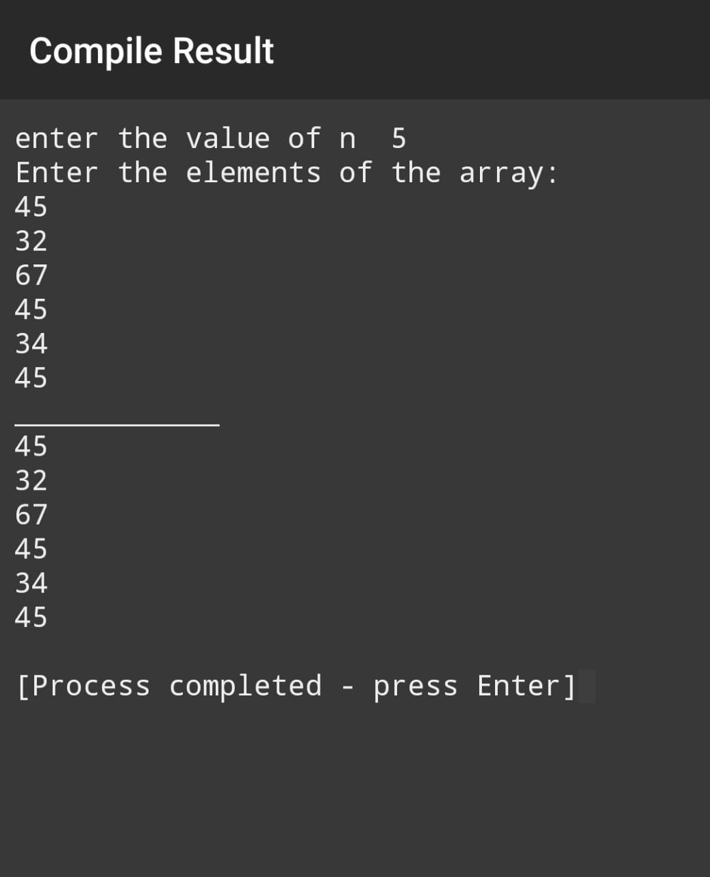

**2ND QUES**

//program for reverse order of an aarray

#include<iostream>

using namespace std;

int main()

{

int i,n,a[n];

cout<<"enter the value of n";

cin>>n;

cout<<"enter value";

for(i=0;i<=n;i++)

{

cin>>a[i];

}

for(i=n;i>=0;i--)

{

cout<<a[i];

}

cout<<"\n";

}

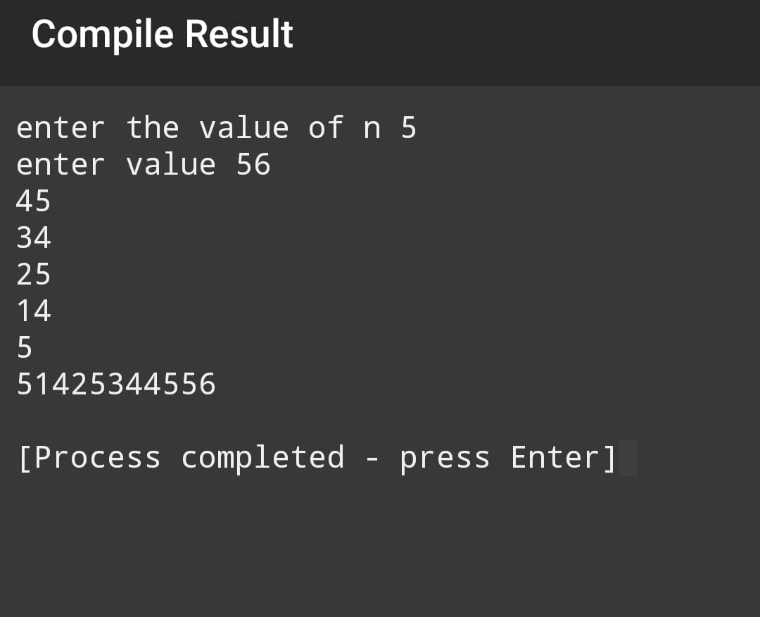

**3RD QUES**

//program for sorting the array

#include<iostream>

using namespace std;

int main()

{

int i, j,t,n;

int arr[n];

cout<<"enter the value of n :";

cin>>n;

cout<<"Enter elements of the array:\n";

for(i=0; i<n; i++)

{

cin>>arr[i];

}

cout<<"Unsorted Order of the array:\n";

for(i=0; i<n; i++)

{

cout<<arr[i]<<" ";

}

for(i=0; i<n; i++)

{

for(j=i+1; j<n; j++)

{

if(arr[i]>arr[j])

{

t=arr[i];

arr[i]=arr[j]; arr[j]=t;

}

}

}

cout<<endl<<endl<<"Sorted Order of the array \n";

for(i=0; i<n; i++)

{

cout<<arr[i]<<" ";

}

}

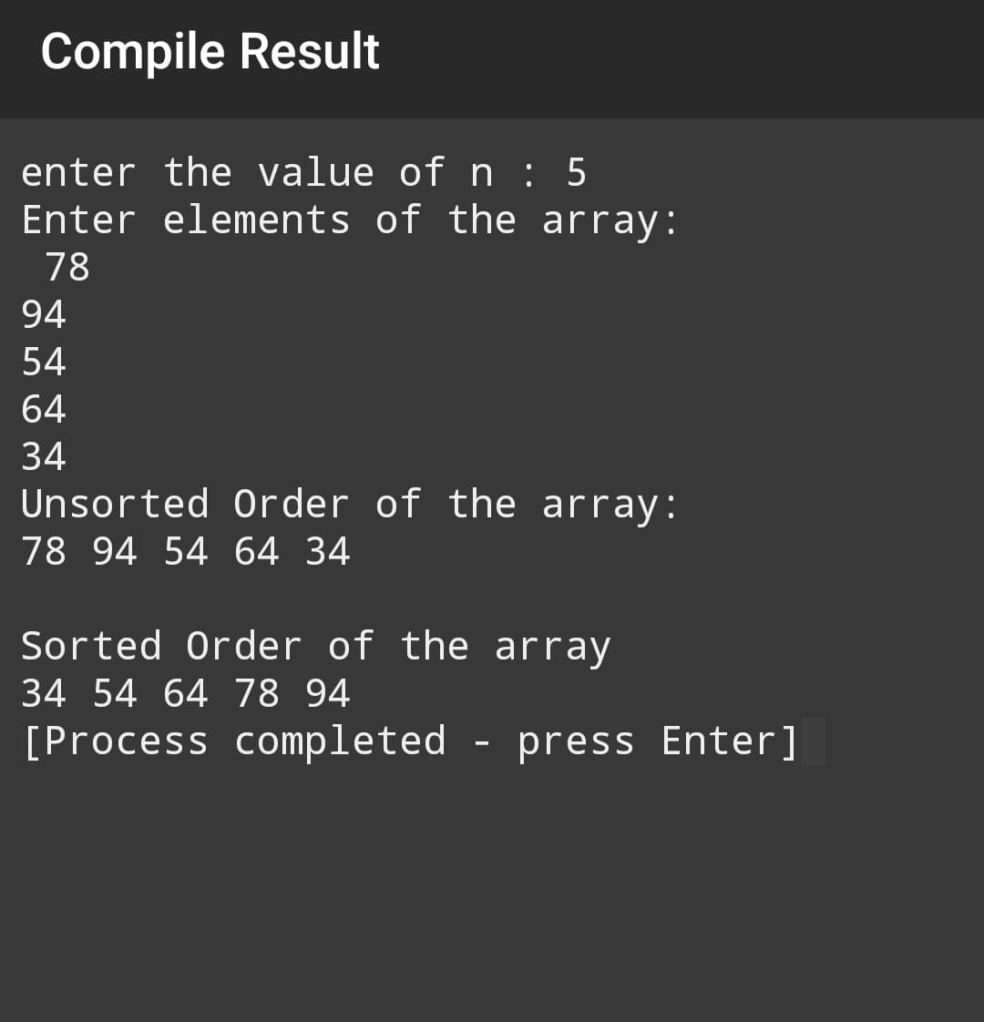

**4TH QUES**

//array program for deletion of an element

#include<iostream>

using namespace std;

int main()

{

int arr [50], n, i, del, count=0;

cout<<"Enter array size : ";

cin>>n;

cout<<"Enter array elements :";

for(i=0; i<n; i++)

{

cin>>arr[i];

}

cout<<"Enter element that we have to delete : ";

cin>>del;

for(i=0; i<n; i++)

{

if(arr[i]==del)

{

for(int j=i; j<(n-1); j++)

{

arr[j]=arr[j+1];

}

count++;

break;

}

}

if(count==0)

{

cout<<"Element not found..!!"; }

else

{

cout<<"Array after deleted the element succesfully..!! \n";

for(i=0; i<(n-1); i++)

{

cout<<arr[i]<<" ";

}

}

return 0;

}

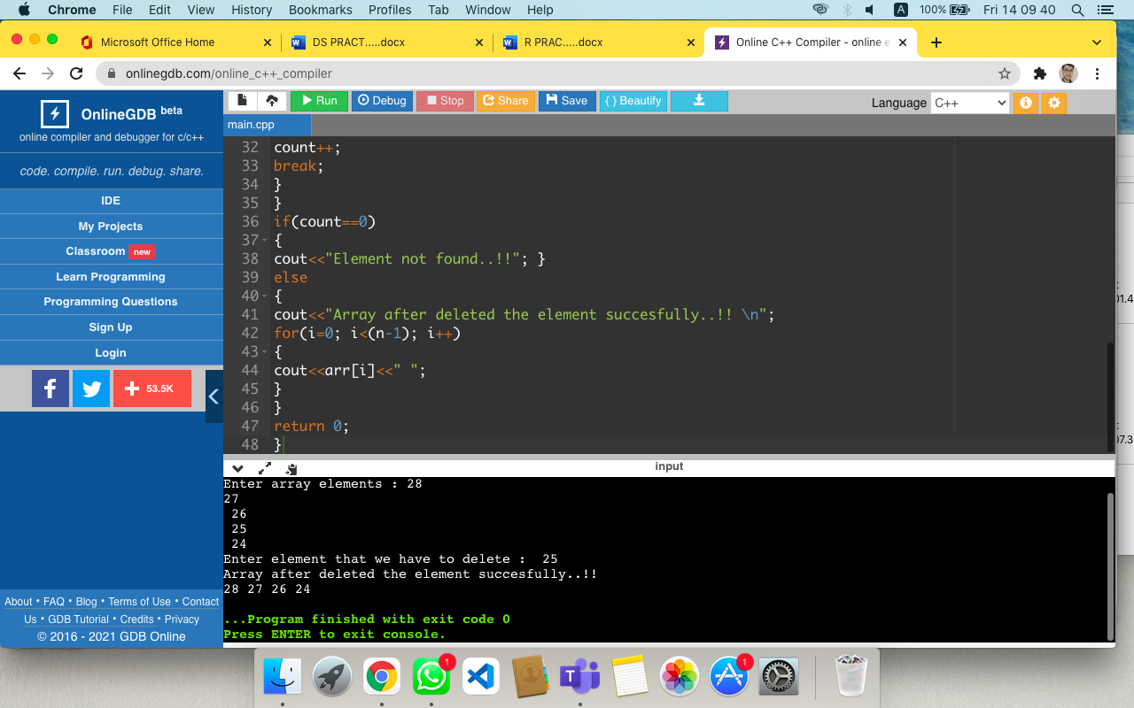

**5TH QUES**

#include<iostream>

#include<conio.h>

Using namespace std;

class array

{

int ar[20],n,i,x;

public:

void display()

{cout<<"enter no of elements you want in the array"<<endl;

cin>>n;

cout<<"enter elements of array";

for(i=0;i<n;i++)

{

cin>>ar[i];

}

cout<<"the elements entered are-";

for(i=0;i<n;i++)

{cout<<ar[i]<<endl;}

}

void del()

{cout<<"enter the position of element you want to delete";

cin>>x;

for(i=0; i<n; i++)

{

if(ar[i]==x)

{

for(int j=i; j<(n-1); j++)

{

ar[j]=ar[j+1];

}

x++;

break;

}

}

if(x==0)

{

cout<<"\nElement not found..!!\n";

}

else

{

cout<<"\nElement deleted successfully..!!\n";

cout<<"\nNow the new array is ::\n";

for(i=0; i<(n-1); i++)

{

cout<<ar[i]<<" ";

}

}

}

};

Int main()

{

clrscr();

array a;

a.display();

a.del();

getch();

}

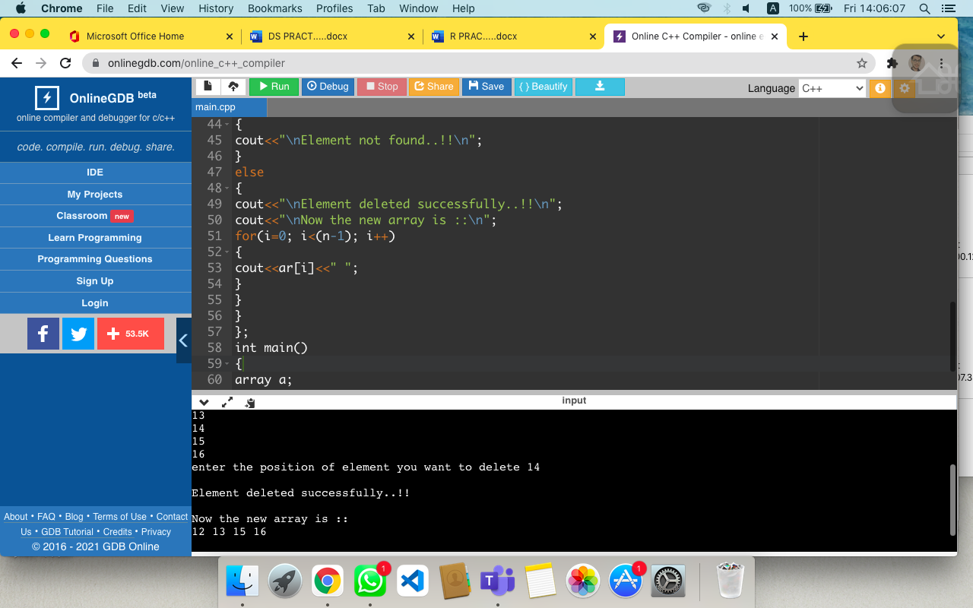

**6TH QUES**

#include<iostream>

using namespace std;

#define MAX 1000

class stack

{

int top,x;

public:

int a[MAX];

stack() {top=-1;}

bool push()

{

cout<<"enter the value of x";

cin>>x;

{

if(top>=(MAX-1))

{

cout<<"stack overflow";

}

else

{

a[++top]=x;

cout<<x<<"pushed into stack\n";

}

}

}

};

int main()

{

int x;

class stack s;

s.push();

//cout<<s.pop()<<"poped from stack \n";

return 0;

}

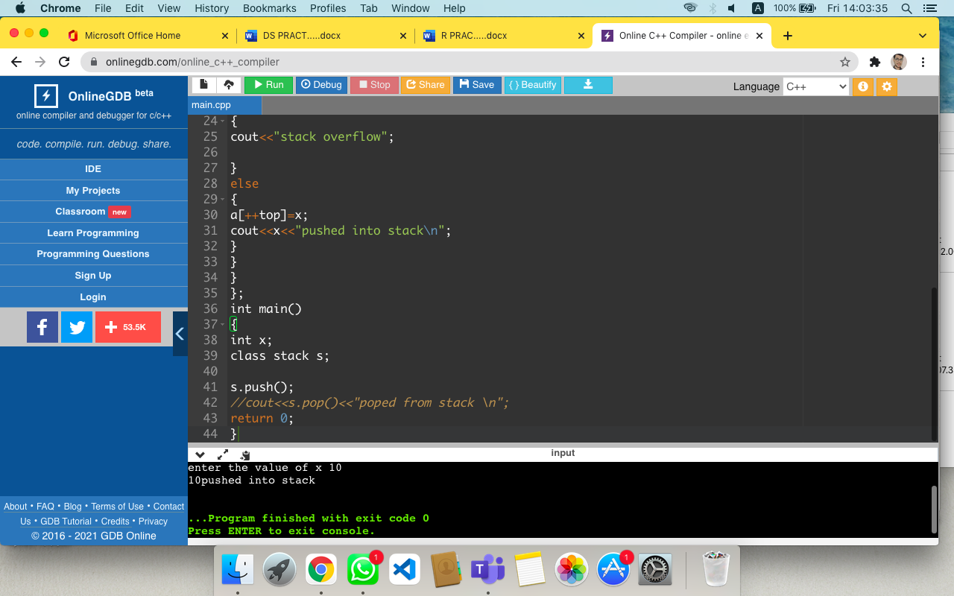

**7TH QUES**

#include<iostream>

using namespace std;

#define MAX 1000

class stack

{

int top;

public:

int a[MAX];

stack() {top=-1;}

bool push(int x);

int pop();

int peek();

bool isEmpty();

};

bool stack::push(int x)

{

if(top>=(MAX-1))

{

cout<<"stack overflow";

return false;

}

else

{

a[++top]=x;

cout<<x<<"pushed into stack\n";

return true;

}

}

int stack::pop()

{

if(top<0)

{

cout<<"stack underflow";

return 0;

}

else{

int x=a[top--];

return true;

}

}

int stack::peek()

{

if(top<0)

{

cout<<"stack is empty";

return 0;

}

else{

int x=a[top];

return x;

}

}

bool stack::isEmpty()

{

return(top<0);

}

int main()

{

class stack s;

s.push(10);

s.push(20);

s.push(30);

cout<<s.pop()<<"poped from stack \n";

return 0;

}

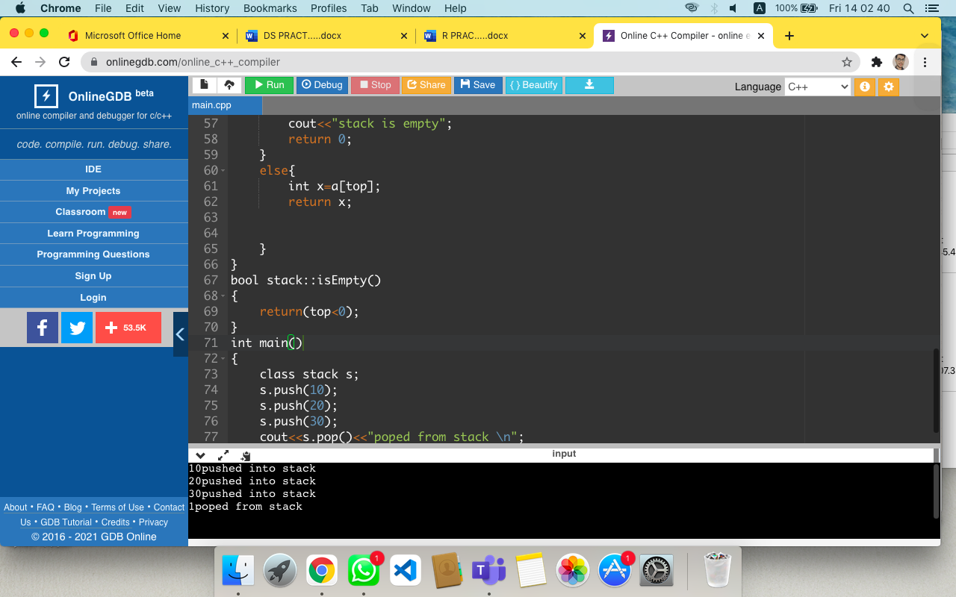

**8TH QUES**

#include <iostream>

#include <stack>

using namespace std;

//function to dispay stack

void dispStack(stack <int> st){

//declare temp. statck

stack <int> s = st;

while(!s.empty()){

cout<<s.top()<<" ";

s.pop();

}

cout<<endl;

}

//Main function for stack program

int main()

{

//declare stack variable

stack <int> st;

//insert elements

st.push(10);

st.push(20);

st.push(30);

st.push(40);

st.push(50);

//display stack coun, top element and stack elements

cout<<"Total stack elements are: "<<st.size()<<endl;

cout<<"Top elements is: "<<st.top()<<endl;

cout<<"All stack elements are: "<<endl;

dispStack(st);

//removing two stack elements

st.pop();

st.pop();

cout<<"\nAfter removing two elements...\n";

//AGAIN....

//display stack coun, top element and stack elements

cout<<"Total stack elements are: "<<st.size()<<endl;

cout<<"Top elements is: "<<st.top()<<endl;

cout<<"All stack elements are: "<<endl;

dispStack(st);

return 0;

}

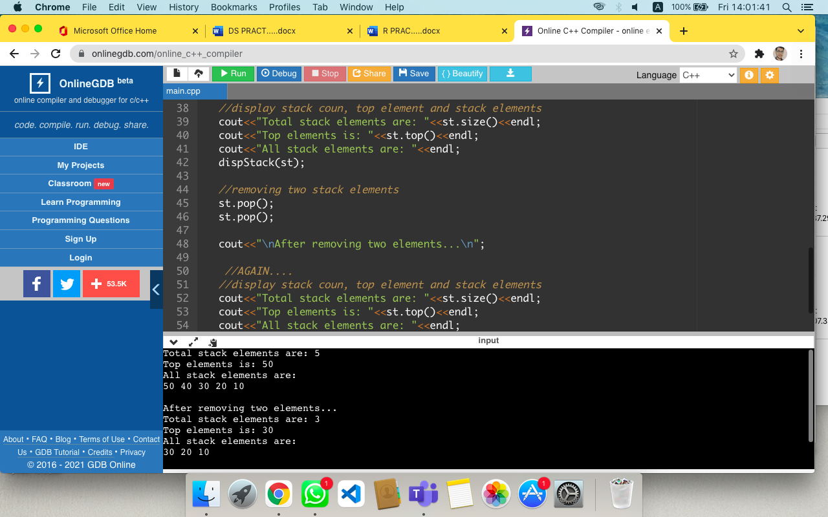

**9TH QUES**

//stack function using stl

#include <iostream>

#include<stack>

using namespace std;

int main()

{

stack<int>s;

s.push(10);

s.push(20);

s.push(30);

s.push(40);

cout<<"the top element of stack are : "<<s.top()<<endl;

cout<<"\n the size of stack are: "<<s.size();

s.pop();

cout<<"\n After the pop operation the top element of stack are : "<<s.top()<<endl;

while(!s.empty())

{

cout<<s.top()<<"\n";

s.pop();

}

cout<<"\n the size of stack are: "<<s.size();

return 0;

}

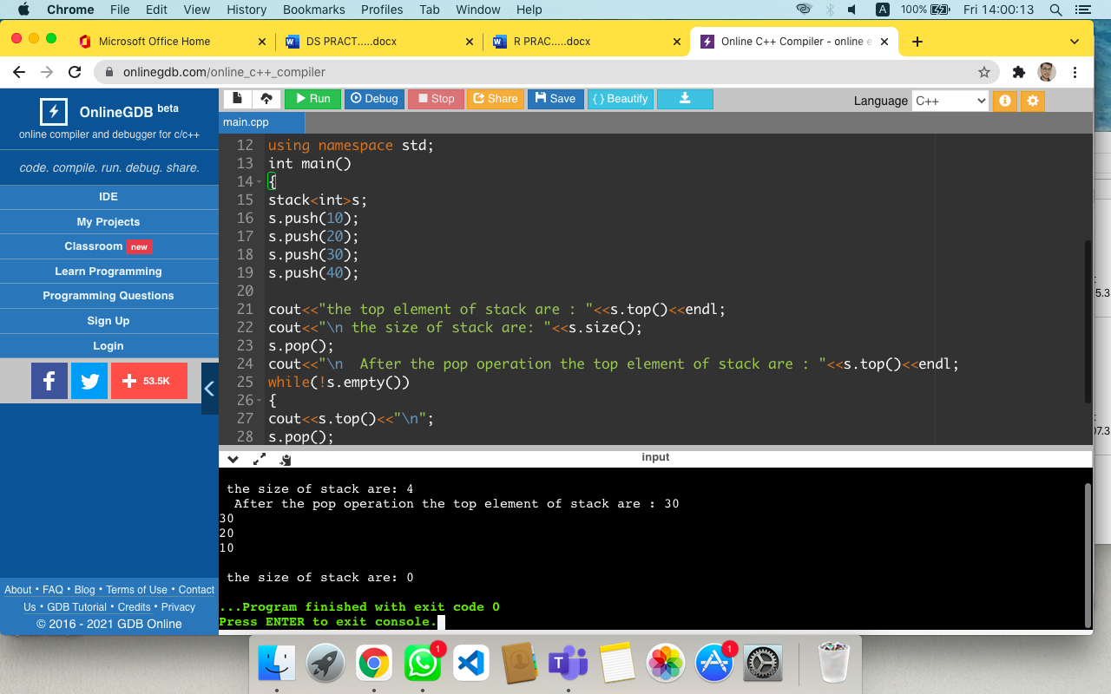

**10TH QUES**

#include<iostream>

#include<stack>

using namespace std;

bool isOperator(char c)

{

if(c=='+'||c=='-'||c=='*'||c=='/'||c=='^')

{

return true;

}

else

{

return false;

}

}

int precedence(char c)

{

if(c == '^')

return 3;

else if(c == '*' || c == '/')

return 2;

else if(c == '+' || c == '-')

return 1;

else

return -1;

}

string InfixToPostfix(stack<char> s, string infix)

{

string postfix;

for(int i=0;i<infix.length();i++)

{

if((infix[i] >= 'a' && infix[i] <= 'z')

||(infix[i] >= 'A' && infix[i] <= 'Z'))

{

postfix+=infix[i];

}

else if(infix[i] == '(')

{

s.push(infix[i]);

}

else if(infix[i] == ')')

{

while((s.top()!='(') && (!s.empty()))

{

char temp=s.top();

postfix+=temp;

s.pop();

}

if(s.top()=='(')

{

s.pop();

}

}

else if(isOperator(infix[i]))

{

if(s.empty())

{

s.push(infix[i]);

}

else

{

if(precedence(infix[i])>precedence(s.top()))

{

s.push(infix[i]);

}

else if((precedence(infix[i])==precedence(s.top()))&&(infix[i]=='^'))

{

s.push(infix[i]);

}

else

{

while((!s.empty())&&( precedence(infix[i])<=precedence(s.top())))

{

postfix+=s.top();

s.pop();

}

s.push(infix[i]);

}

}

}

}

while(!s.empty())

{

postfix+=s.top();

s.pop();

}

return postfix;

}

int main()

{

string infix_exp, postfix_exp;

cout<<"Enter a Infix Expression :"<<endl;

cin>>infix_exp;

stack <char> stack;

cout<<"INFIX EXPRESSION: "<<infix_exp<<endl;

postfix_exp = InfixToPostfix(stack, infix_exp);

cout<<endl<<"POSTFIX EXPRESSION: "<<postfix_exp<<endl;

return 0;

}

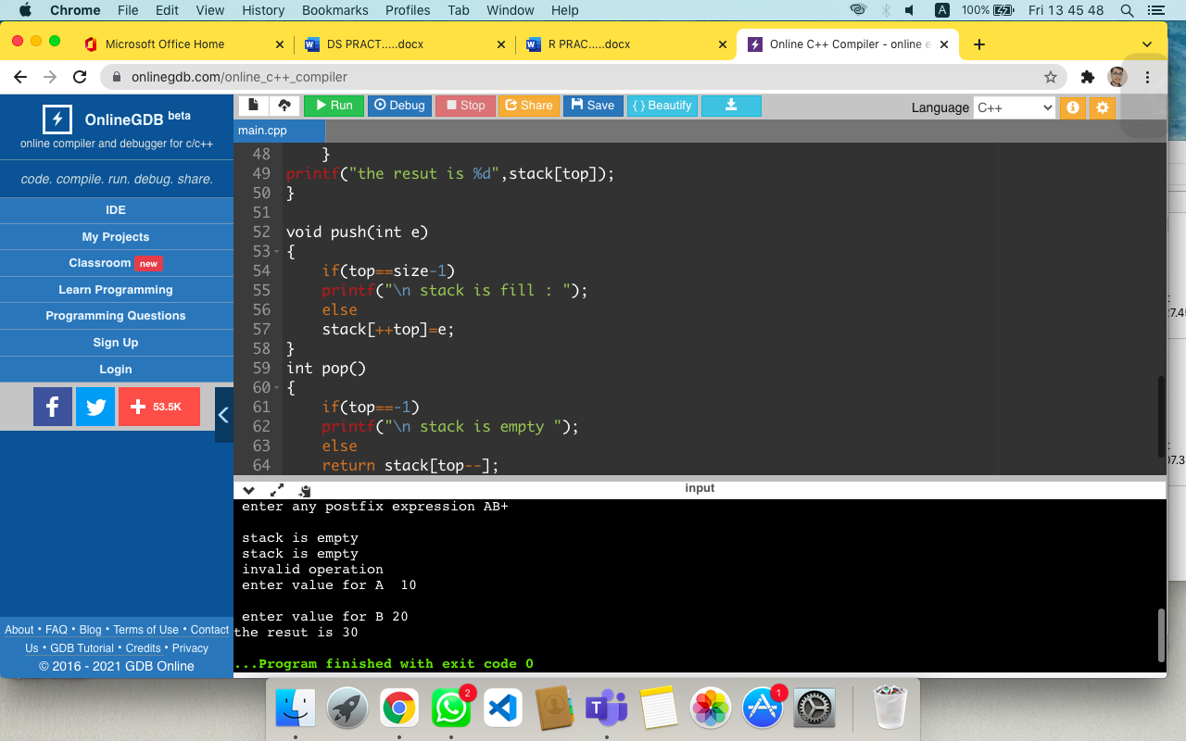

**11TH QUES**

#include <stdio.h>

#include <ctype.h>

#define size 100

int stack[size],top=-1;

void push(int e);

int pop();

void main()

{

char pe[30];

int i,v,op1,op2;

printf("\n enter any postfix expression");

gets(pe);

for(i=0;pe[i]!='\0';i++)

{

if(isalpha(pe[i]))

{

printf("\n enter value for %c",pe[i]);

scanf("%d",&v);

push(v);

}

else if (isdigit(pe[i]))

push(pe[i]-'0');

else

{

op2=pop();

op1=pop();

switch(pe[i])

{

case '+':push(op1+op2);break;

case '-':push(op1-op2);break;

case '*':push(op1*op2);break;

case '/':push(op1/op2);break;

case '%':push(op1%op2);break;

case '^':push(op1^op2);break;

default: printf("\n invalid operation");

}

}

}

printf("the resut is %d",stack[top]);

}

void push(int e)

{

if(top==size-1)

printf("\n stack is fill : ");

else

stack[++top]=e;

}

int pop()

{

if(top==-1)

printf("\n stack is empty ");

else

return stack[top--];

}

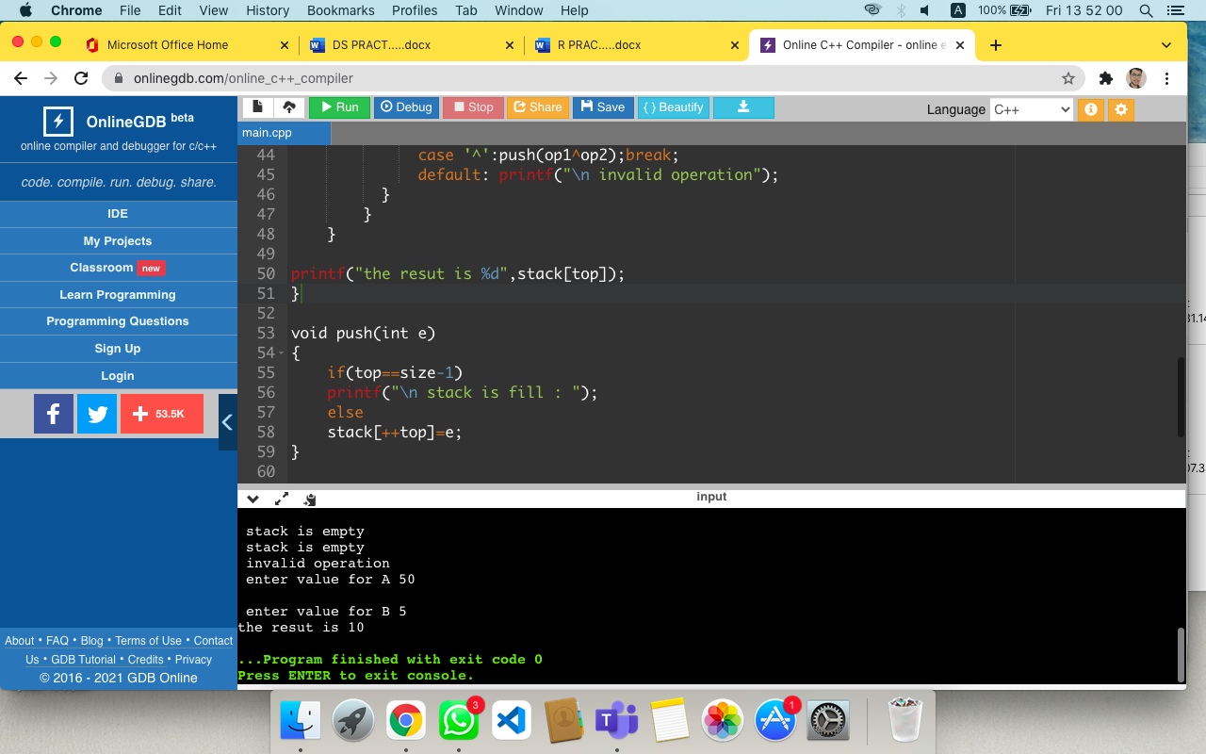

**12TH QUES**

#include <iostream>

using namespace std;

class Queue{

private:

int front;

int rear;

int arr[5];

public:

Queue()

{

front=-1;

rear=-1;

for(int i =0;i<5;i++)

{

arr[i]=0;

}

}

bool isEmpty()

{

if(front==-1 && rear==-1)

return true;

else

return false;

}

bool isFull()

{

if(rear==4)

return true;

else

return false;

}

void enqueue(int val)

{

if(isFull())

{

cout<<"Queue is Full"<<endl;

return;

}

else if(isEmpty())

{

rear=0;

front=0;

arr[rear]=val;

}

else

{

rear++;

arr[rear]=val;

}

}

int Dequeue()

{

int x;

if(isEmpty())

{

cout<<"Queue is Empty "<<endl;

return 0;

}

else if(front==rear)

{

x=arr[front] ;

arr[front]=0;

rear=-1;

front=-1;

return x;

}

else

{

x=arr[front] ;

arr[front]=0;

front++;

return x;

}

}

int count()

{

return (rear-front+1);

}

void display()

{

cout<<"a value in the queue are - "<<endl;

for(int i =0;i<5;i++)

{

cout<<arr[i]<<" ";

}

}

};

int main()

{

Queue q1;

int option,value;

do

{

cout <<" \n\n What operation do u want to perform ? select option number ,enter 0 to exit" << std::endl;

cout<<"1.enqueue()"<<endl;

cout<<"2.Dequeue()"<<endl;

cout<<"3.isEmpty()"<<endl;

cout<<"4.isFull()"<<endl;

cout<<"5.count()"<<endl;

cout<<"6.display()"<<endl;

cout<<"7.clear screen()"<<endl;

cin>>option;

switch(option)

{

case 0:

break;

case 1:

cout<<"enqueue operation \n Enter an item t enqueue in the queue "<<endl;

cin>>value;

q1.enqueue(value);

break;

case 2:

cout<<"Dequeue operation \nDequeue value : "<<q1.Dequeue()<<endl;

break;

case 3:

if(q1.isEmpty())

cout<<"Queue is Empty "<<endl;

else

cout<<"Queue is not Empty "<<endl;

break;

case 4:

if(q1.isFull())

cout<<"Queue is Full"<<endl;

else

cout<<"Queue is not Full"<<endl;

break;

case 5:

cout<<"count operation \n count of items in queue :"<<q1.count()<<endl;

break;

case 6:

cout<<"Display function called "<<endl;

q1.display();

break;

case 7:

system("cls");

break;

default:

cout<<"enter proper option number "<<endl;

break;

}

}

while(option!=0);

return 0;

}

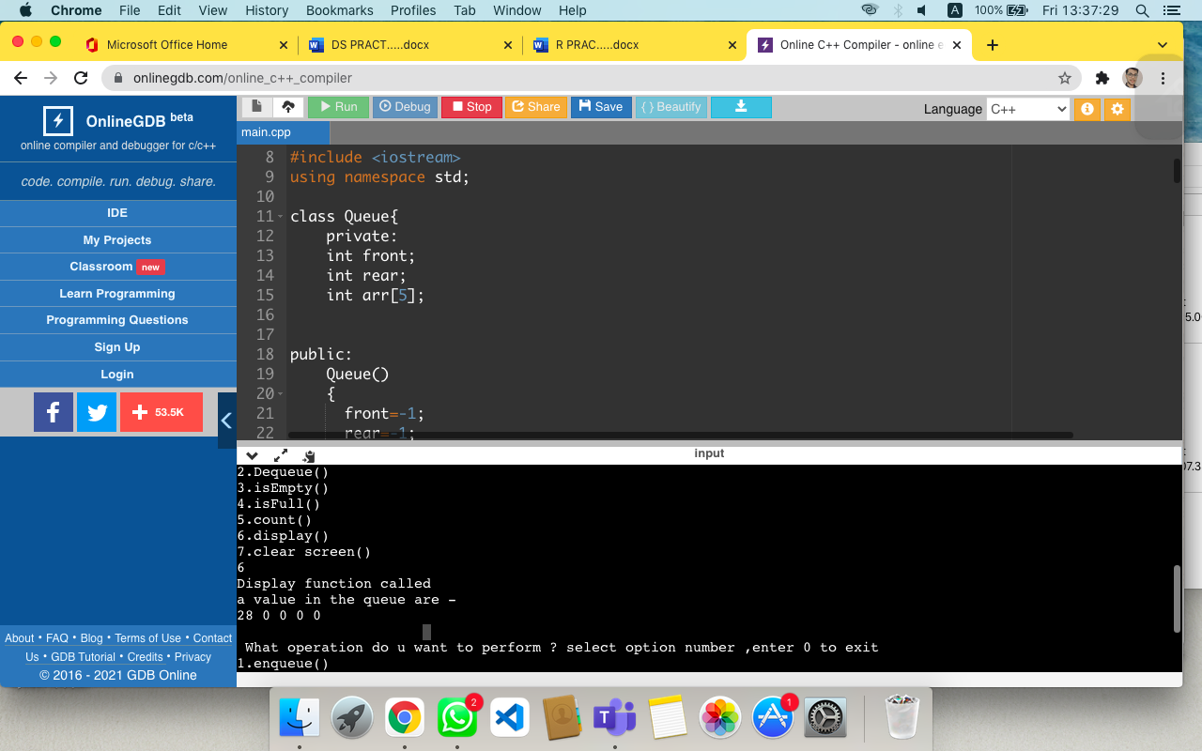

**13TH QUES**

#include<iostream>

#include<stdlib.h>

using namespace std;

class cqueue

{

int q[5],front,rare;

public:

cqueue()

{

front=-1;

rare=-1;

}

void enque(int x)

{

if(front ==-1 && rare == -1)

{

q[++rare]=x;

front=rare;

return;

}

else if(front == (rare+1)%5 )

{

cout <<" Circular Queue over flow";

return;

}

rare= (rare+1)%5;

q[rare]=x;

}

void deque()

{

if(front==-1 && rare== -1)

{

cout <<"under flow";

return;

}

else if( front== rare )

{

front=rare=-1;

return;

}

front= (front+1)%5;

}

void display()

{

int i;

if( front <= rare)

{

for(i=front; i<=rare;i++)

cout << q[i]<<" ";

}

else

{

for(i=front;i<=4;i++)

{

cout <<q[i] << " ";

}

for(i=0;i<=rare;i++)

{

cout << q[i]<< " ";

}

}

}

};

int main()

{

int ch;

cqueue q1;

while( 1)

{

cout<<"\n1.INSERT \n2.DELETE \n3.DISPLAY \n4.EXIT\nEnter ur choice";

cin >> ch;

switch(ch)

{

case 1: cout<<"enter element";

cin >> ch;

q1.enque(ch); break;

case 2: q1.deque(); break;

case 3: q1.display(); break;

case 4: exit(0);

}

}

return 0;

}

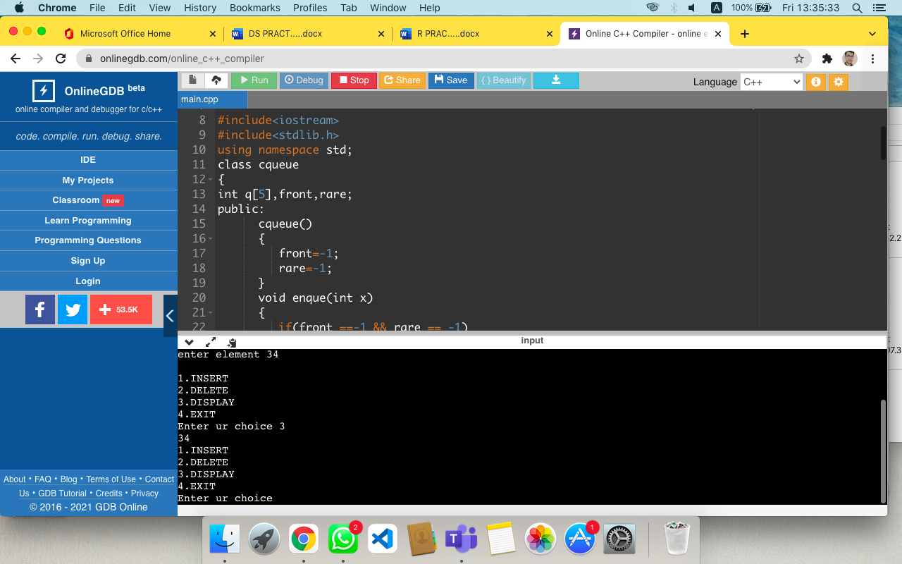

**14TH QUES**

#include <iostream>

using namespace std;

struct node

{

int data; //Self referencial node

node *next,*info;

};

class linked_list

{

private:

node *head ,*tail;

public:

linked_list()

{

head=NULL;

tail=NULL;

}

void add_node(int n)

{

node *tmp = new node;

tmp->data = n;

tmp->next = NULL;

if(head==NULL)

{

head = tmp;

tail = tmp;

}

else

{

tail->next=tmp;

tail=tail->next;

}

}

void insert()

{

node *prev,*cur;

node *first,*last;

prev = NULL;

cur = head;

int count = 1,pos,ch,n;

node *tmp = new node;

cout<<"\n Enter an element : ";

cin>>n;

tmp -> data = n;

tmp->next =NULL;

cout<<"\n INSERTAS\n 1:FIRSTNODE\n 2:LASTNODE\n3:IN BETWEEN FIRST & LAST NODES";

cout<<"\n enter your choice : ";

cin>>ch;

switch (ch)

{

case 1:

tmp-> next = head;

first = tmp;

break;

case 2:

last->next=tmp;

last=tmp;

break;

case 3:

cout<<"\n enter the position to insert : ";

cin>>pos;

while(count != pos)

{

prev = cur;

cur = cur -> next;

count++;

}

if(count==pos)

{

prev->next=tmp;

tmp->next=cur;

}

else

cout<<"\n Not able to insert :";

break;

}

}

void deletion()

{

node *prev = NULL,*cur = head,*info;

int count =1,pos,ch;

cout<<"\n DELETE \n1:FIRSTNODE\n 2:LASTNODE\n3:IN BETWEEN FIRST & LAST NODES";

cout<<"\n enter your choice : ";

cin>>ch;

switch(ch)

{

case 1:

if (head != NULL)

{

cout<<"\n deleted element is "<<head->info;

head = head->next;

}

else

cout<<"\n not able to delete ";

break;

case 2:

while(cur != tail)

{

prev = cur;

cur = cur ->next;

}

if(cur == tail)

{

cout<<"\n deleted element is :"<<cur->info;

prev->next=NULL;

tail = prev;

}

else

cout<<"\n not able to delete ";

break;

case 3:

cout<<"\n enter the position of deletion :";

cin>>pos;

while(count != pos)

{

prev = cur;

cur = cur -> next;

count++;

}

if ( count == pos)

{

cout<<"\n deleted element is :"<<cur->info;

prev -> next = cur -> next;

}

else

cout<<"\n not able to delete";

break;

}

}

void display()

{

node *tmp;

tmp = head;

while(tmp != NULL)

{

cout<<tmp->data;

tmp = tmp -> next;

}

}

};

int main()

{

linked_list a;

a.add_node(27);

a.add_node(19);

a.add_node(28);

a.add_node(8);

a.insert();

a.deletion();

a.display();

return 0;

}

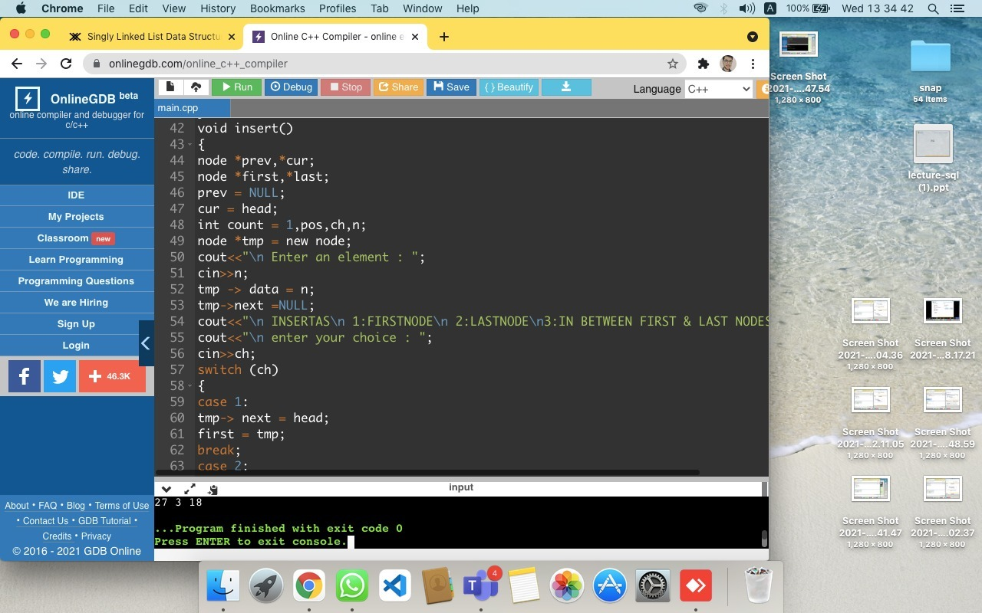

**15TH QUES**

#include <iostream>

using namespace std;

struct node

{

int data; //Self referencial node

node *next,*info;

};

class linked_list

{

private:

node *head ,*tail;

public:

linked_list()

{

head=NULL;

tail=NULL;

}

void add_node(int n)

{

node *tmp = new node;

tmp->data = n;

tmp->next = NULL;

if(head==NULL)

{

head = tmp;

tail = tmp;

}

else

{

tail->next=tmp;

tail=tail->next;

}

}

void insert()

{

node *prev,*cur;

node *first,*last;

prev = NULL;

cur = head;

int count = 1,pos,ch,n;

node *tmp = new node;

cout<<"\n Enter an element : ";

cin>>n;

tmp -> data = n;

tmp->next =NULL;

cout<<"\n INSERTAS\n 1:FIRSTNODE\n 2:LASTNODE\n3:IN BETWEEN FIRST & LAST NODES";

cout<<"\n enter your choice : ";

cin>>ch;

switch (ch)

{

case 1:

tmp-> next = head;

first = tmp;

break;

case 2:

last->next=tmp;

last=tmp;

break;

case 3:

cout<<"\n enter the position to insert : ";

cin>>pos;

while(count != pos)

{

prev = cur;

cur = cur -> next;

count++;

}

if(count==pos)

{

prev->next=tmp;

tmp->next=cur;

}

else

cout<<"\n Not able to insert :";

break;

}

}

void deletion()

{

node *prev = NULL,*cur = head,*info;

int count =1,pos,ch;

cout<<"\n DELETE \n1:FIRSTNODE\n 2:LASTNODE\n3:IN BETWEEN FIRST & LAST NODES";

cout<<"\n enter your choice : ";

cin>>ch;

switch(ch)

{

case 1:

if (head != NULL)

{

cout<<"\n deleted element is "<<head->info;

head = head->next;

}

else

cout<<"\n not able to delete ";

break;

case 2:

while(cur != tail)

{

prev = cur;

cur = cur ->next;

}

if(cur == tail)

{

cout<<"\n deleted element is :"<<cur->info;

prev->next=NULL;

tail = prev;

}

else

cout<<"\n not able to delete ";

break;

case 3:

cout<<"\n enter the position of deletion :";

cin>>pos;

while(count != pos)

{

prev = cur;

cur = cur -> next;

count++;

}

if ( count == pos)

{

cout<<"\n deleted element is :"<<cur->info;

prev -> next = cur -> next;

}

else

cout<<"\n not able to delete";

break;

}

}

void display()

{

node *tmp;

tmp = head;

while(tmp != NULL)

{

cout<<tmp->data<<" ";

tmp = tmp -> next;

}

}

};

int main()

{

linked_list a;

a.add_node(27);

a.add_node(19);

a.add_node(28);

a.add_node(8);

a.insert();

a.display();

a.deletion();

a.display();

return 0;

}

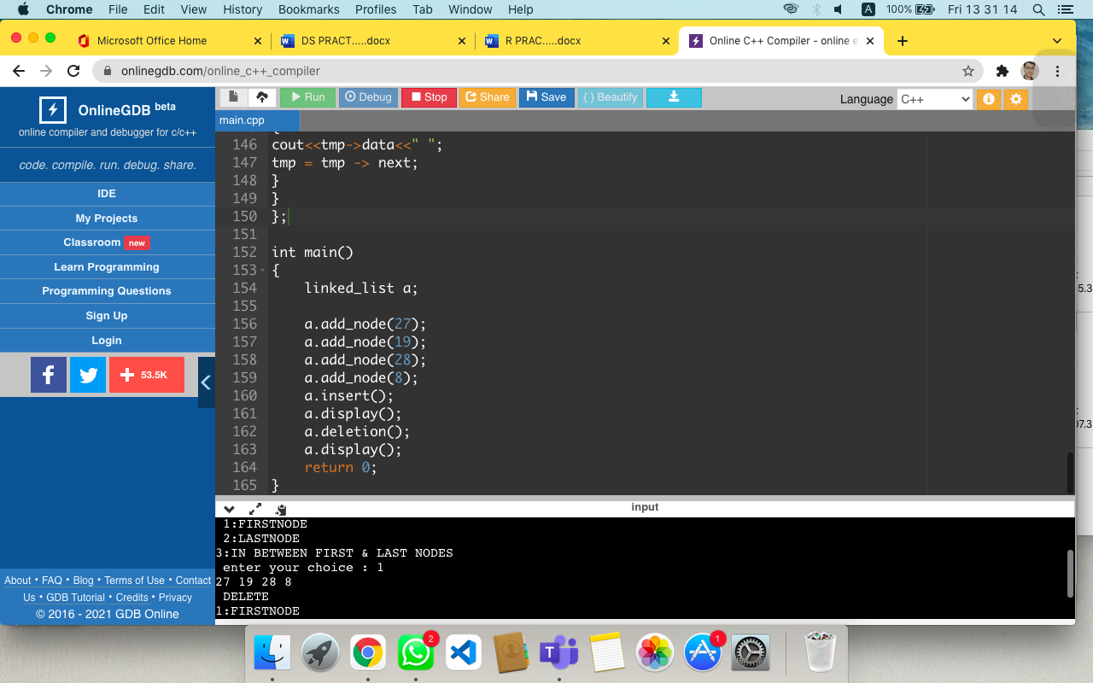

**16TH QUES**

//double linked list progrm

#include <iostream>

#include<malloc.h>

using namespace std;

//node declaration

struct node

{

int info; //Self referencial node

struct node *next;

struct node *prev;

}*start;

//class declaration

class double_list

{

public:

void create_list(int value);

void display_dlist();

double_list()

{

start = NULL;

}

};

void double_list::create_list(int value)

{

struct node *s,*temp;

temp = new(struct node);

temp -> info = value;

temp -> next = NULL;

if (start ==NULL)

{

temp -> prev = NULL;

start = temp;

}

else

{

s = start;

while(s -> next != NULL)

s = s -> next;

s -> next = temp;

temp -> prev = s;

}

}

void double_list:: display_dlist()

{

struct node *q;

if (start == NULL)

{

cout<<"List empty , nothing to display "<<endl;

return;

}

q = start;

cout<<"the doubly link list is : "<<endl;

while(q != NULL)

{

cout<<q->info<<"<->";

q = q->next;

}

cout<<"NULL"<<endl;

}

//main method

int main()

{

int element;

double_list dl;

cout<<"enter the element :";

cin>>element;

dl.create_list(element);

cout<<endl;

dl.display_dlist();

}

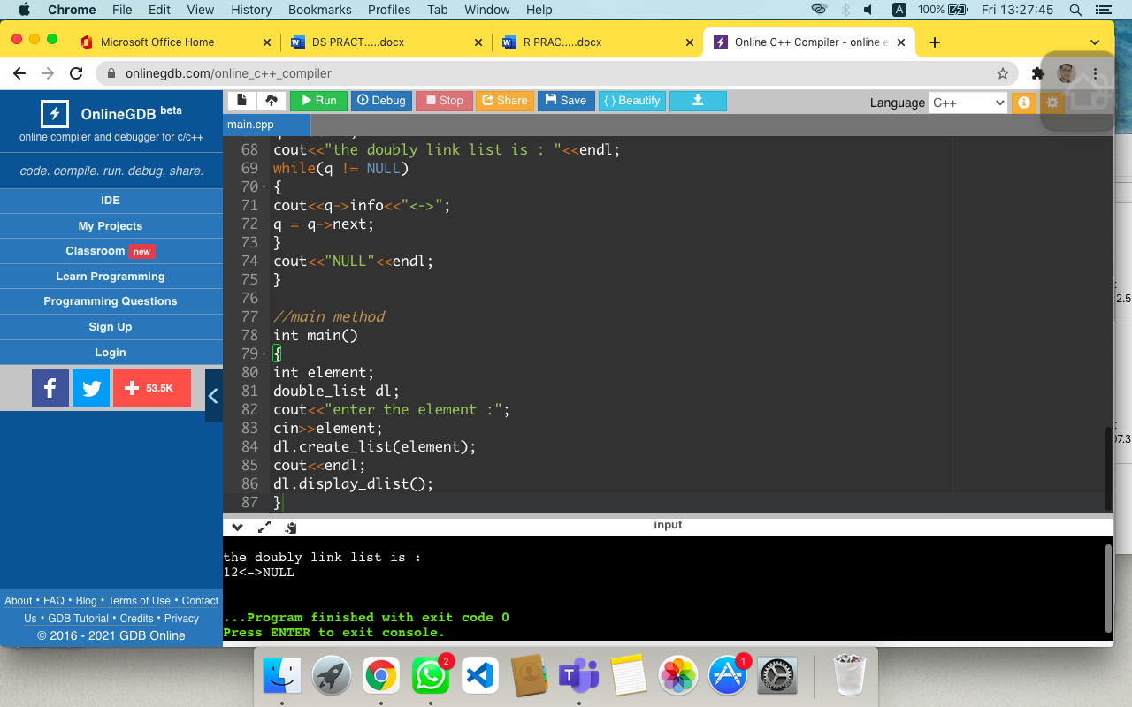

**17TH QUES**

#include<iostream>

using namespace std;

#define MAXSIZE 10

class Stack{

int arr[MAXSIZE];

int top;

public:

Stack()

{

top=-1;

}

void push(int x)

{

if(top==MAXSIZE-1){

cout<<"Stack Overflow"<<endl;

}

else

{

top=top+1;

arr[top]=x;

}

}

int pop(){

if(top==-1){

cout<<"Stack underflow"<<endl;

}

else

{

return (arr[top]);

top=top-1;

}

}

bool empty()

{

return top==-1;

}

void display(){

if(top==-1){

cout<<"Stack does not contain any element"<<endl;

}

else

{

for(int i=top; i>=0; i--)

cout<<arr[i];

}

}

};

int main()

{

Stack obj;

obj.push(5);

obj.push(7);

obj.push(88);

obj.pop();

obj.display();

}

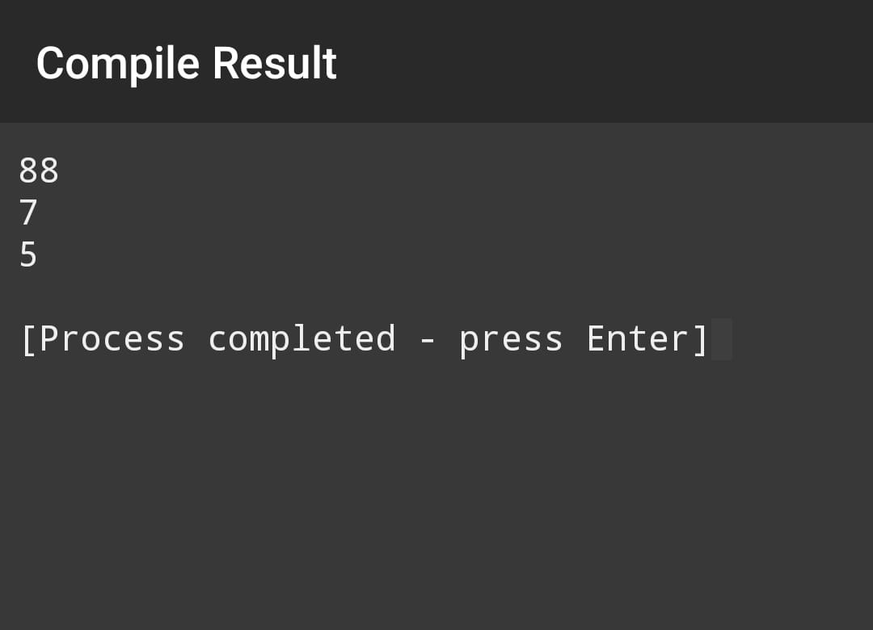

**18TH QUES**

//stack program using linked list

#include<iostream>

#include<stdlib.h>

using namespace std;

struct node{

int data;

struct node *next;

};

struct node *createstack()

{

return NULL;

}

void push(struct node **top,int val)

{

struct node temp=(struct node)malloc(sizeof(struct node));

if(!temp)

return ;

temp->data=val;

temp->next=*top;

*top=temp;

}

int IsEmptyStack(struct node **top)

{

return top==NULL;

}

int pop(struct node **top)

{

struct node *temp;

int val;

if(IsEmptyStack(top))

return NULL;

temp=*top;

*top=(*top)->next;

val=temp->data;

free(temp);

cout<<val<<" ";

return val;

}

void display(struct node **top)

{

struct node *p=*top;

while(p!=NULL)

{

cout<<p->data<<" ";

p=p->next;

}

}

int main()

{

int r;

struct node *top=NULL;

push(&top,30);

push(&top,40);

push(&top,50);

r=pop(&top);

cout<<"the popped value is:-"<<r<<endl;

cout<<"the data in stack is:-";

display(&top);

return 0;

}

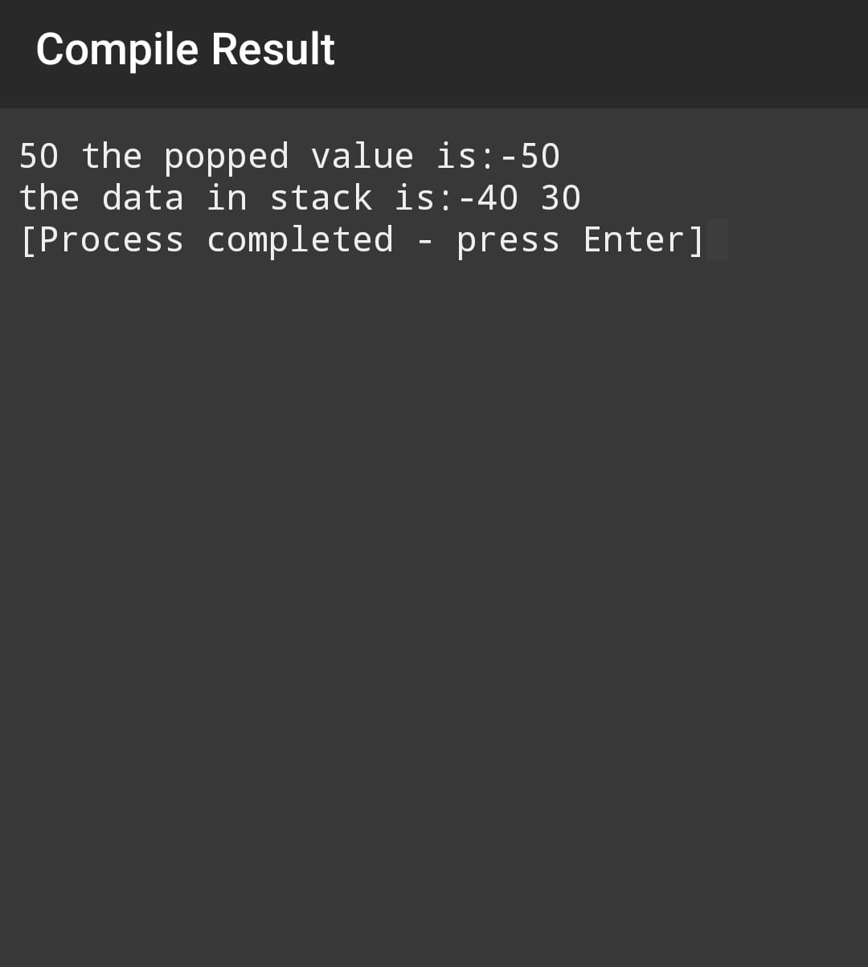

**19TH QUES**

#include <bits/stdc++.h>

using namespace std;

class node

{

public:

int data;

node *prev;

node *next;

node(int val)

{

data = val;

prev=0;

next=0;

}

};

void insertAthead(node* &head,int val)

{

node * p = new node(val);

p->next=head;

if(head!=NULL)

{

head->prev=p;

}

head=p;

}

void insertAtTail(node* &head,int val)

{

if(head == NULL)

{

insertAthead(head,val);

return;

}

node * p = new node(val);

node *temp = head;

while(temp->next!=0)

{

temp=temp->next;

}

temp->next=p;

p->prev=temp;

}

void display(node* head)

{

node *temp = head;

while(temp!=NULL)

{

cout<<temp->data<<" ";

temp=temp->next;

// cout<<temp->data<<" ";

}

}

void deleteAthead(node *&head )

{

node* todelete = head;

head=head->next;

head->prev=0;

delete(todelete);

}

void Delete(node * &head , int pos)

{

if(pos==1)

{

deleteAthead(head);

return;

}

node* temp = head;

int count = 1;

while(temp!=NULL&&count!=pos)

{

temp=temp->next;

count++;

}

// temp=temp->next;

temp->prev->next=temp->next;

if(temp->next!=NULL)

temp->next->prev=temp->prev;

delete(temp);

}

void insertAt(node *&head,int val,int pos)

{

node *p=new node(val);

node *temp = head;

int count=1;

while(temp!=0&&count!=pos)

{

temp=temp->next;

count++;

}

if(temp->next==NULL)

{

insertAtTail(head,val);

return;

}

p->next=temp->next;

temp->next->prev=p;

p->prev=temp;

temp->next=p;

}

int main()

{

node *head = NULL;

insertAtTail(head,32);

insertAtTail(head,33);

insertAtTail(head,34);

insertAtTail(head,34);

insertAthead(head,5);

display(head);

Delete(head,2);

cout<<"yes "<<endl;

display(head);

Delete(head,1);

cout<<"yes "<<endl;

display(head);

insertAt(head,100,3);

cout<<"yes "<<endl;

display(head);

return 0;

}

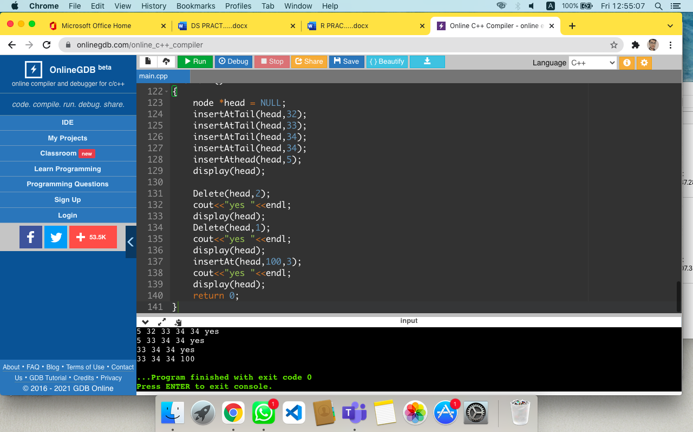

**20TH QUES**

#include <iostream>

#include<malloc.h>

using namespace std;

//node declaration

struct node

{

int info; //Self referencial node

struct node *next;

struct node *prev;

}*start;

//class declaration

class double_list

{

public:

void create_list(int value);

void add_begin(int value);

void add_after(int value,int pos);

void display_dlist();

double_list()

{

start=NULL;

}

};

void double_list::create_list(int value)

{

struct node *s,*temp;

temp = new(struct node);

temp -> info = value;

temp -> next = NULL;

if (start ==NULL)

{

temp -> prev = NULL;

start = temp;

}

else

{

s = start;

while(s -> next != NULL)

s = s -> next;

s -> next = temp;

temp -> prev = s;

}

}

void double_list::add_begin(int value)

{

if(start == NULL)

{

cout<<"first create the link"<<endl;

return;

}

struct node *temp;

temp=new(struct node);

temp->prev =NULL;

temp->info=value;

temp->next=start;

start->prev = temp;

start=temp;

cout<<"element inserted"<<endl;

}

void double_list::add_after(int value,int pos)

{

if (start=NULL)

{

cout<<"first create the list "<< endl;

return;

}

struct node *temp,*q;

int i;

q = start;

for(i=0;i<pos-1;i++)

{

q=q->next;

if(q==NULL)

{

cout<<"there are less than ";

cout<<pos<<"element"<<endl;

return;

}

}

temp=new(struct node);

temp->info=value;

if(q->next==NULL)

{

q->next=temp;

temp->next=NULL;

temp->prev = q;

}

else

{

temp->next=q->next;

temp->next->prev=temp;

q->next=temp;

temp->prev=q;

}

cout<<"element inserted "<<endl;

}

void double_list:: display_dlist()

{

struct node *q;

if (start == NULL)

{

cout<<"List empty,nothing to display "<<endl;

return;

}

q = start;

cout<<"the doubly link list is : "<<endl;

while(q != NULL)

{

cout<<q->info<<"<->";

q = q->next;

}

cout<<"NULL"<<endl;

}

//main method

int main()

{

int element,pos;

double_list dl;

cout<<"Enter the element :";

cin>>element;

dl.create_list(element);

cout<<endl;

dl.display_dlist();

cout<<"insert value at beg :";

cin>>element;

dl.add_begin(element);

cout<<endl;

dl.display_dlist();

cout<<" element which we have to insert value at any location";

cin>>element;

cout<<"Enter the position where we want to insert ";

cin>> pos;

cout<<endl;

dl.add_after(element ,pos);

dl.display_dlist();

}

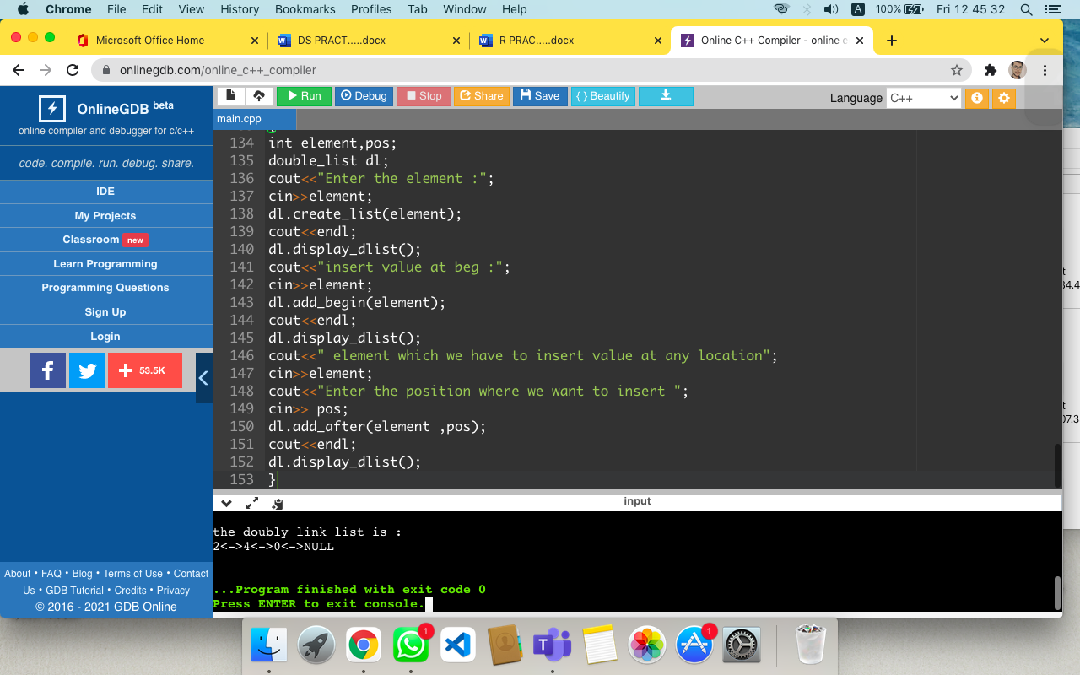

**21ST QUES**

#include <iostream>

#include<malloc.h>

using namespace std;

//node declaration

struct node

{

int info; //Self referencial node

struct node *next;

struct node *prev;

}*start;

//class declaration

class double_list

{

public:

void create_list(int value);

void add_begin(int value);

void add_after(int value,int pos);

void display_dlist();

double_list()

{

start=NULL;

}

};

void double_list::create_list(int value)

{

struct node *s,*temp;

temp = new(struct node);

temp -> info = value;

temp -> next = NULL;

if (start ==NULL)

{

temp -> prev = NULL;

start = temp;

}

else

{

s = start;

while(s -> next != NULL)

s = s -> next;

s -> next = temp;

temp -> prev = s;

}

}

void double_list::add_begin(int value)

{

if(start == NULL)

{

cout<<"first create the link"<<endl;

return;

}

struct node *temp;

temp=new(struct node);

temp->prev =NULL;

temp->info=value;

temp->next=start;

start->prev = temp;

start=temp;

cout<<"element inserted"<<endl;

}

void double_list::add_after(int value,int pos)

{

if (start=NULL)

{

cout<<"first create the list "<< endl;

return;

}

struct node *temp,*q;

int i;

q = start;

for(i=0;i<pos-1;i++)

{

q=q->next;

if(q==NULL)

{

cout<<"there are less than ";

cout<<pos<<"element"<<endl;

return;

}

}

temp=new(struct node);

temp->info=value;

if(q->next==NULL)

{

q->next=temp;

temp->next=NULL;

temp->prev = q;

}

else

{

temp->next=q->next;

temp->next->prev=temp;

q->next=temp;

temp->prev=q;

}

cout<<"element inserted "<<endl;

}

void double_list:: display_dlist()

{

struct node *q;

if (start == NULL)

{

cout<<"List empty,nothing to display "<<endl;

return;

}

q = start;

cout<<"the doubly link list is : "<<endl;

while(q != NULL)

{

cout<<q->info<<"<->";

q = q->next;

}

cout<<"NULL"<<endl;

}

//main method

int main()

{

int element,pos;

double_list dl;

cout<<"Enter the element :";

cin>>element;

dl.create_list(element);

cout<<endl;

dl.display_dlist();

cout<<"insert value at beg :";

cin>>element;

dl.add_begin(element);

cout<<endl;

dl.display_dlist();

cout<<" element which we have to insert value at any location";

cin>>element;

cout<<"Enter the position where we want to insert ";

cin>> pos;

cout<<endl;

dl.add_after(element ,pos);

dl.display_dlist();

}



**22ND QUES**

#include <iostream>

#include<malloc.h>

using namespace std;

//node declaration

struct node

{

int info; //Self referencial node

struct node *next;

struct node *prev;

}*start;

//class declaration

class double_list

{

public:

void create_list(int value);

void add_begin(int value);

//void add_after(int value,int pos);

void display_dlist();

double_list()

{

start=NULL;

}

};

void double_list::create_list(int value)

{

struct node *s,*temp;

temp = new(struct node);

temp -> info = value;

temp -> next = NULL;

if (start ==NULL)

{

temp -> prev = NULL;

start = temp;

}

else

{

s = start;

while(s -> next != NULL)

s = s -> next;

s -> next = temp;

temp -> prev = s;

}

}

void double_list::add_begin(int value)

{

if(start == NULL)

{

cout<<"first create the link"<<endl;

return;

}

struct node *temp;

temp=new(struct node);

temp->prev =NULL;

temp->info=value;

temp->next=start;

start->prev = temp;

start=temp;

cout<<"element inserted"<<endl;

}

void double_list:: display_dlist()

{

struct node *q;

if (start == NULL)

{

cout<<"List empty,nothing to display "<<endl;

return;

}

q = start;

cout<<"the doubly link list is : "<<endl;

while(q != NULL)

{

cout<<q->info<<"<->";

q = q->next;

}

cout<<"NULL"<<endl;

}

//main method

int main()

{

int element,pos;

double_list dl;

cout<<"Enter the element :";

cin>>element;

dl.create_list(element);

cout<<endl;

dl.display_dlist();

cout<<"insert value at beg :";

cin>>element;

dl.add_begin(element);

cout<<endl;

dl.display_dlist();

}



**23RD QUES**

#include<iostream>

#include<queue>

#include<string>

using namespace std;

int main()

{

queue<string>weekdays;

weekdays.push("Saturday");

weekdays.push("Friday");

weekdays.push("Thursday");

weekdays.push("Wednesday");

weekdays.push("Tuesday");

weekdays.push("Monday");

weekdays.push("Sunday");

cout<<"size of the stack:"<<weekdays.size()<<endl;

while(!weekdays.empty())

{

cout<<weekdays.front()<<endl;

weekdays.pop();

}

}

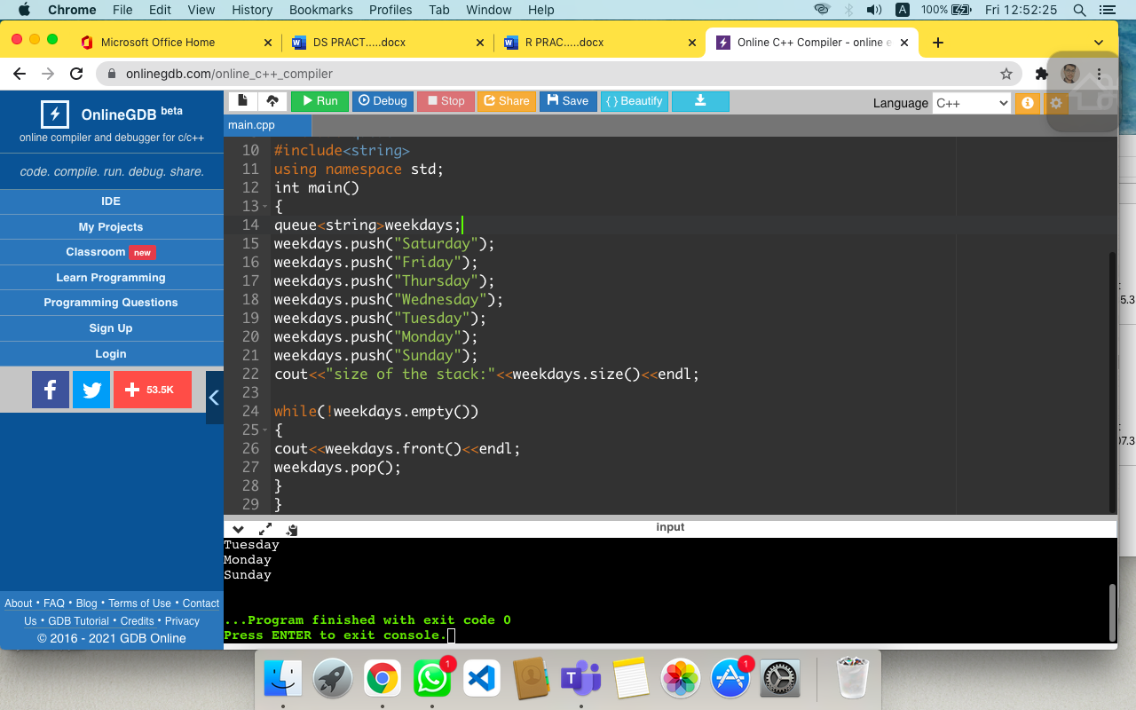

**24TH QUES**

//linkedlist creation nd insertion of the element

#include

<iostream>

#include<malloc.h>

using namespace std;

//node declaration

struct node

{

int info; //Self referencial node

struct node *next;

struct node *prev;

}*start;

//class declaration

class double_list

{

public:

void create_list(int value);

void add_begin(int value);

void add_after(int value,int pos);

void add_last(int value);

void display_dlist();

double_list()

{

start=NULL;

}

};

//creation of double linkedlist

void double_list::create_list(int value)

{

struct node *s,*temp;

temp = new(struct node);

temp -> info = value;

temp -> next = NULL;

if (start == NULL)

{

temp -> prev = NULL;

start = temp;

}

else

{

s = start;

while(s -> next != NULL)

s = s -> next;

s -> next = temp;

temp -> prev = s;

}

}

// insertion in beggning

void double_list::add_begin(int value)

{

if(start == NULL)

{

cout<<"first create the link"<<endl;

return;

}

struct node *temp;

temp=new(struct node);

temp->prev =NULL;

temp->info=value;

temp->next=start;

start->prev = temp;

start=temp;

cout<<"element inserted"<<endl;

}

//insertion in between the linked list

void double_list::add_after(int value,int pos)

{

if (start == NULL)

{

cout<<"first create the list "<< endl;

return;

}

struct node *temp,*q;

int i;

q = start;

for(i=0;i<pos-1;i++)

{

q=q->next;

if(q==NULL)

{

cout<<"there are less than ";

cout<<pos<<"element"<<endl;

return;

}

}

temp=new(struct node);

temp->info=value;

if(q->next==NULL)

{

q->next=temp;

temp->next=NULL;

temp->prev = q;

temp=q;

}

else

{

temp->next=q->next;

temp->next->prev=temp;

q->next=temp;

temp->prev=q;

}

cout<<"element inserted "<<endl;

}

//insertion at last position

void double_list::add_last(int value)

{

if(start == NULL)

{

cout<<"first create the link"<<endl;

return;

}

struct node *temp,*r;

temp=new(struct node);

temp=start;

r=new(struct node);

r->info=value;

while( temp->next!=NULL)

{

temp=temp->next;

}

temp->next = r;

r->prev=temp;

r->next=NULL;

cout<<"element inserted"<<endl;

}

void double_list:: display_dlist()

{

struct node *q;

if (start == NULL)

{

cout<<"List empty,nothing to display "<<endl;

return;

}

q = start;

cout<<"the doubly link list is : "<<endl;

while(q != NULL)

{

cout<<q->info<<"<->";

q = q->next;

}

cout<<"NULL"<<endl;

}

//main method

int main()

{

int element,pos;

double_list dl;

cout<<"Enter the element :";

cin>>element;

dl.create_list(element);

cout<<endl;

dl.display_dlist();

cout<<"insert value at beg :";

cin>>element;

dl.add_begin(element);

cout<<endl;

dl.display_dlist();

cout<<" element which we have to insert at any location";

cin>>element;

cout<<"Enter the position where we want to insert ";

cin>> pos;

dl.add_after(element ,pos);

cout<<endl;

dl.display_dlist();

cout<<"insert value at last :";

cin>>element;

dl.add_last(element);

cout<<endl;

dl.display_dlist();

}

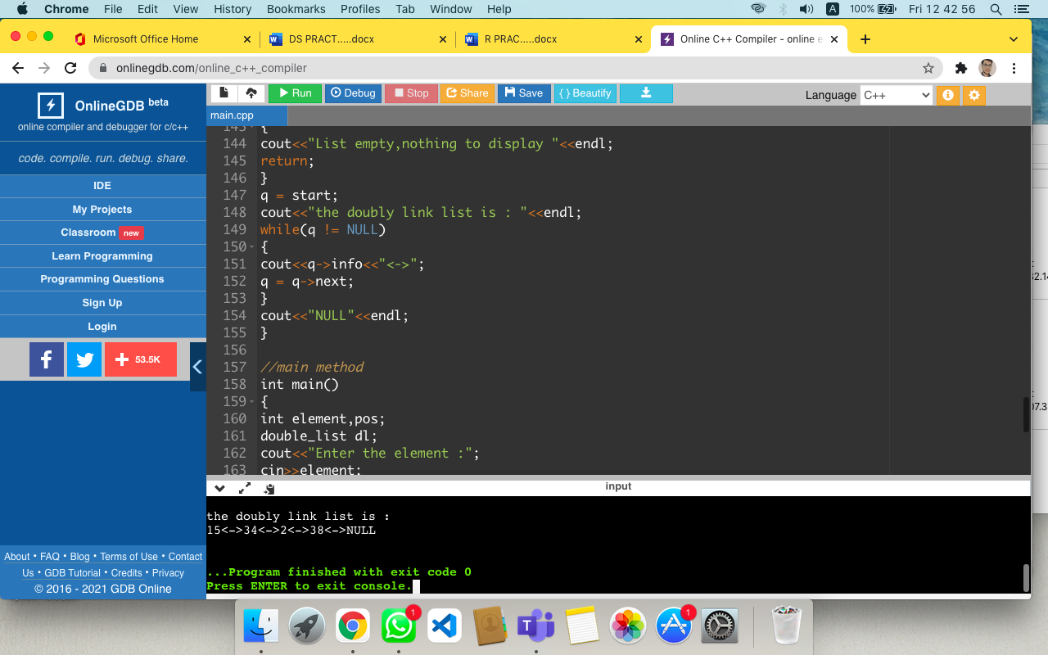

**25TH QUES**

//prgram for deletion operaTION IN DOUBLE LINKLIST

#include <iostream>

#include<malloc.h>

using namespace std;

//node declaration

struct node

{

int info; //Self referencial node

struct node *next;

struct node *prev;

}*start;

//class declaration

class double_list

{

public:

void create_list(int value);

void delete_beg();

void delete_inbtw(int value,int pos);

void delete_atlast();

void display_dlist();

double_list()

{

start=NULL;

}

};

//creation of double linkedlist

void double_list::create_list(int value)

{

struct node *s,*temp;

temp = new(struct node);

temp -> info = value;

temp -> next = NULL;

if (start == NULL)

{

temp -> prev = NULL;

start = temp;

}

else

{

s = start;

while(s -> next != NULL)

s = s -> next;

s -> next = temp;

temp -> prev = s;

}

}

// deletion in beggning

void double_list :: delete_beg()

{

if(start == NULL)

{

cout<<"this is null link list "<<endl;

return;

}

struct node *temp;

temp=start;

start=start->next;

start->prev = NULL;

delete(temp);

cout<<"element deleted"<<endl;

}

//deletion in at any position

void double_list :: delete_inbtw(int value,int pos)

{

if(start == NULL)

{

cout<<"this is null link list "<<endl;

return;

}

struct node *temp,*r;

int i;

temp=start;

for(i=0;i<pos;i++)

{

r=temp;

temp=temp->next;

}

r->next = temp->next;

r->next=temp->next;

temp->next->prev = r->next;

if(temp->next!=NULL);

temp->next->prev=temp->prev;

delete(temp);

}

// deletion in at last position

void double_list :: delete_atlast()

{

if(start == NULL)

{

cout<<"this is null link list "<<endl;

return;

}

struct node *temp,*s;

temp=start;

while(temp->next != NULL)

{

s=temp;

temp=temp->next;

}

s->next=NULL;

temp->prev=NULL;

delete(temp);

cout<<"Node deleted from end ";

}

void double_list::display_dlist()

{

struct node *q;

if (start == NULL)

{

cout<<"List empty,nothing to display "<<endl;

return;

}

q = start;

cout<<"the doubly link list is : "<<endl;

while(q != NULL)

{

cout<<q->info<<"<->";

q = q->next;

}

cout<<"NULL"<<endl;

}

//main method

int main()

{

int element,pos;

double_list dl;

cout<<"Enter the element :";

cin>>element;

dl.create_list(element);

dl.create_list(11);

dl.create_list(12);

dl.create_list(13);

dl.create_list(14);

dl.create_list(15);

dl.display_dlist();

dl.delete_beg();

cout<<endl;

dl.display_dlist();

cout<<"enter the element which u have to delete";

cin>>element;

cout<<"enter the position of the element ";

cin>>pos;

dl.delete_inbtw(element,pos);

cout<<endl;

dl.display_dlist();

cout<<endl;

dl.delete_atlast();

cout<<endl;

dl.display_dlist();

}

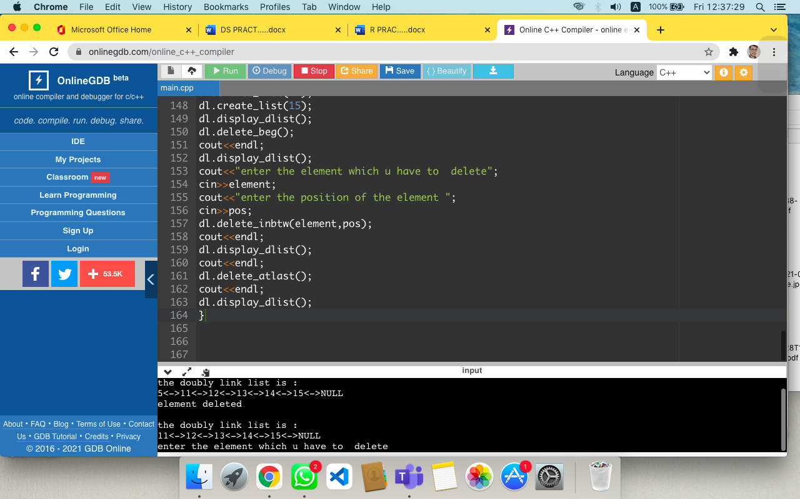

**26TH QUES**

//program for stack using linklist

#include <iostream>

using namespace std;

struct Node

{

int data;

struct Node* link;

};

struct Node* top;

void push(int data)

{

struct Node* temp;

temp = new Node();

if (!temp)

{

cout << "\nStack Overflow";

exit(1);

}

temp->data = data;

temp->link = top;

top = temp;

}

int isEmpty()

{

return top == NULL;

}

int peek()

{

if (!isEmpty())

return top->data;

else

exit(1);

}

void pop()

{

struct Node* temp;

if (top == NULL)

{

cout << "\nStack Underflow" << endl;

exit;

}

else

{

temp = top;

top = top->link;

temp->link = NULL;

free(temp);

}

}

void display()

{

struct Node* temp;

if (top == NULL)

{

cout << "\nStack Underflow";

exit(1);

}

else

{

temp = top;

while (temp != NULL)

{

cout<<temp->data<< "-> ";

temp=temp->link;

}

}

}

int main()

{

push(27);

push(19);

push(07);

push(28);

display();

cout<<"\nTop element of stack is "<<peek()<<endl;

pop();

pop();

display();

cout<<"\nTop element of stack is "<<peek()<<endl;

return 0;

}

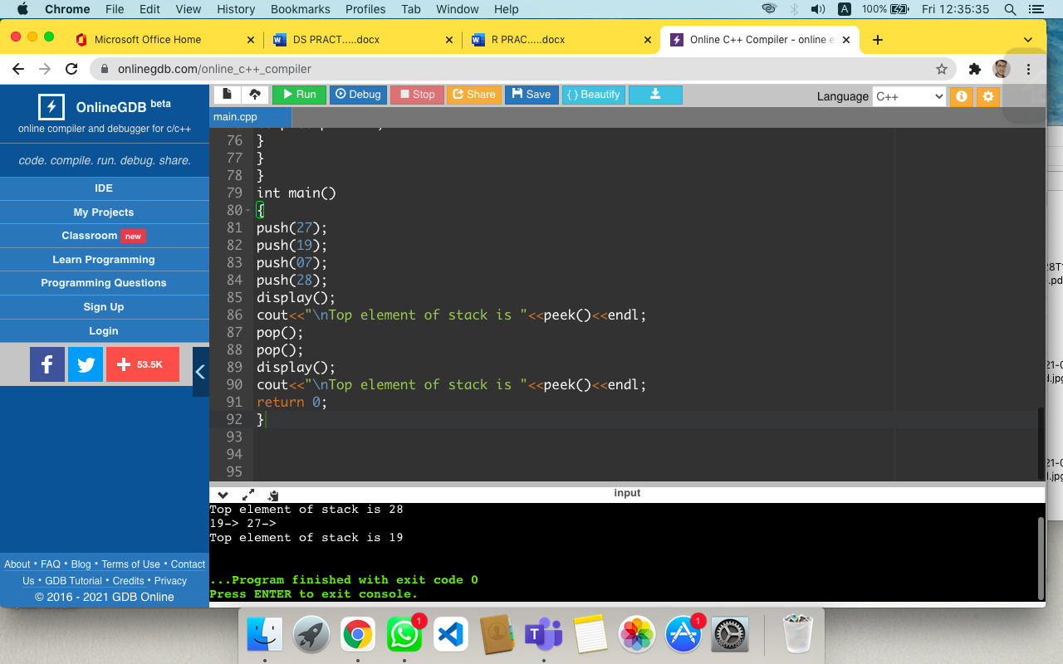

**27TH QUES**

//queue using link list

#include <iostream>

using namespace std;

struct QNode {

int data;

QNode* next;

QNode(int d)

{

data = d;

next = NULL;

}

};

struct Queue {

QNode *front, *rear;

Queue()

{

front = rear = NULL;

}

void enQueue(int x)

{

QNode* temp = new QNode(x);

if (rear == NULL) {

front = rear = temp;

return;

}

rear->next = temp;

rear = temp;

}

void deQueue()

{

if (front == NULL)

return;

QNode* temp = front;

front = front->next;

if (front == NULL)

rear = NULL;

delete (temp);

}

};

int main()

{

Queue q;

q.enQueue(10);

q.enQueue(20);

q.enQueue(30);

q.enQueue(40);

q.enQueue(50);

q.deQueue();

q.deQueue();

q.deQueue();

cout << "Front element of queue : " << (q.front)->data << endl;

cout << " Rear element of queue : " << (q.rear)->data;

}

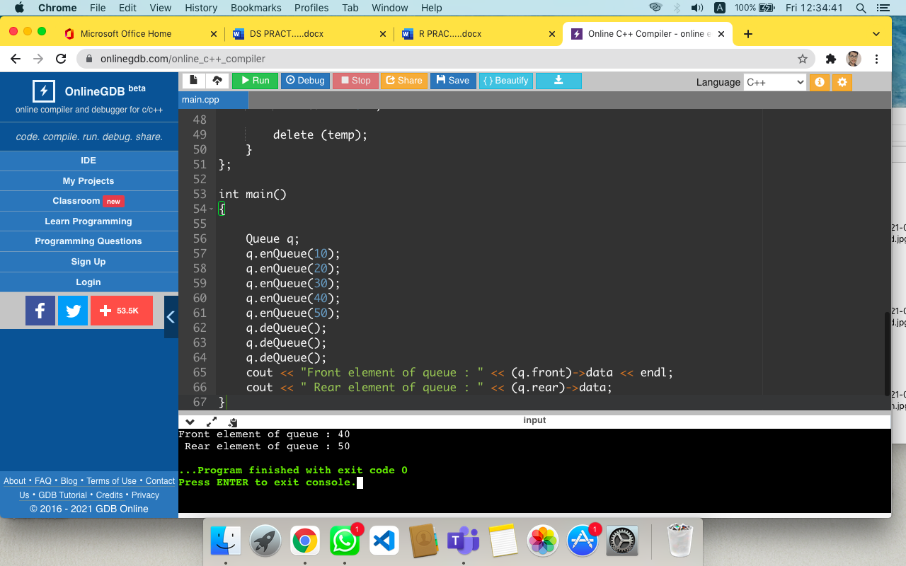

**28TH QUES**

#include<iostream>

using namespace std;

#include<stack>

Void display(stack<int>st)

{

stack<int>p=st;

while(!p.empty())

{

cout<<p.top()<<"";

p.pop();

}

cout<<"\n";

}

int main()

{

stack<int>s;

s.push(2);

s.push(4);

s.push(1);

display (s);

s.pop();

cout<<s.top()<<"\n";

stack<int>s1;

s1.push(9);

s1.push(67);

swap(s,s1);

display(s);

}

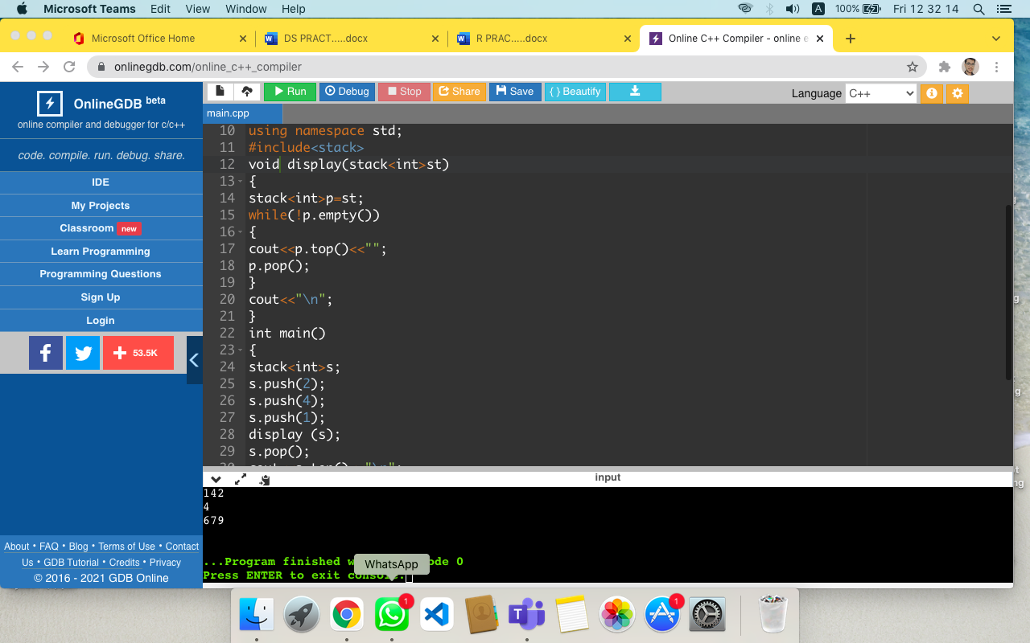

**29TH QUES**

#include<iostream>

#include<queue>

#include<string>

using namespace std;

int main()

{

priority_queue<int>nums;

nums.push(9);

nums.push(2);

nums.push(7);

nums.push(1);

nums.push(4);

cout<<"size of the stack:"<<nums.size()<<endl;

while(!nums.empty())

{

cout<<nums.top()<<endl;

nums.pop();

}

}

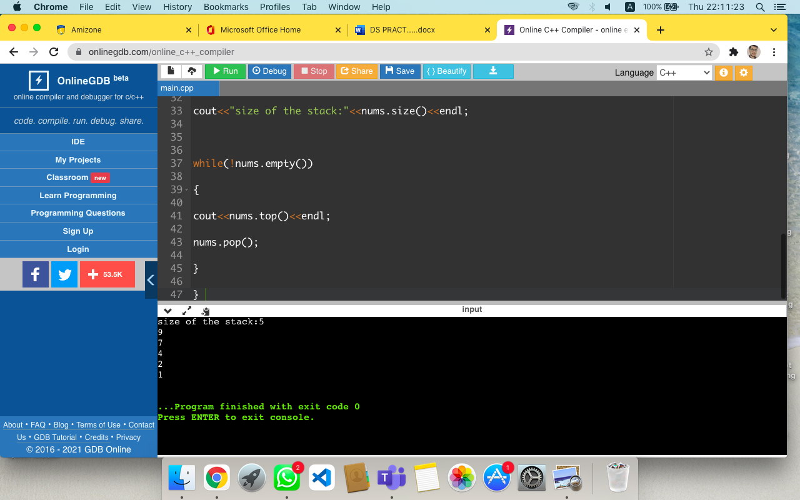

**30 TH QUES**

#include<iostream>

#include<vector>

using namespace std ;

int main()

{

vector <int> vg;

for(int i=1;i<=5;i++)

vg.push_back(i);

cout<<"output of begin and end :";

for(auto i = vg.begin();i!=vg.end(); ++i)

cout<<*i<<"";

cout<<"\n output of cbegin and cend :";

for(auto i = vg.cbegin();i!=vg.cend(); ++i)

cout<<*i<<"";

cout<<"\n output of rbegin and rend :";

for(auto ir = vg.rbegin();ir!=vg.rend(); ++ir)

cout<<*ir<<"";

cout<<"\noutput of crbegin and crend :";

for(auto ir = vg.crbegin();ir!=vg.crend(); ++ir)

cout<<*ir<<"";

return 0;

}

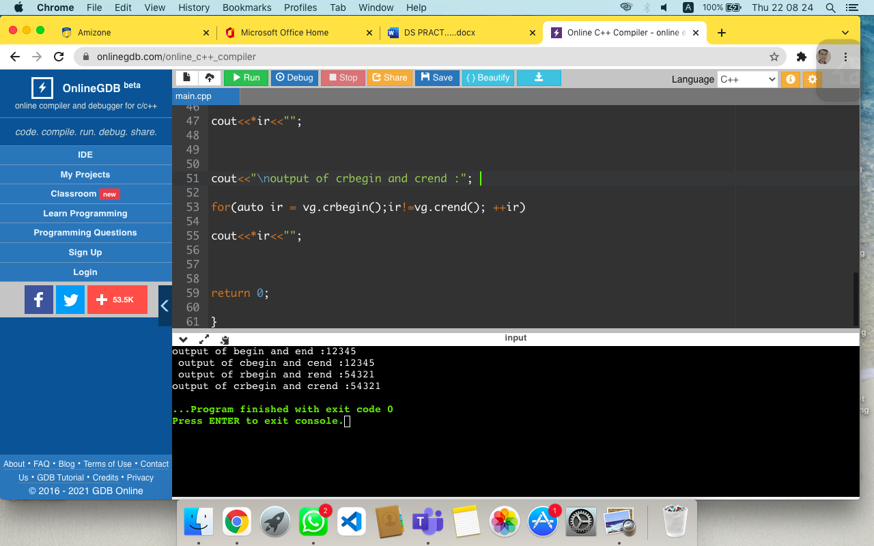

**31ST QUES**

#include<iostream>

#include<vector>

using namespace std ;

int main()

{

vector <int> rp={1,2,3,4,5};

vector <int> pr={10,20,30,40,50};

cout<<"the vector1 elements before swapping operation are :";

for(int i =0;i<rp.size();++i)

cout<<rp[i]<<"\n";

cout<<"\nthe vector2 elements before swapping operation are :";

for(int i =0;i<rp.size();++i)

cout<<pr[i]<<"\n";

swap(rp,pr);

cout<<"\nthe vector1 elements after swapping operation are :";

for(int i =0;i<rp.size();i++)

cout<<rp[i]<<"\n";

cout<<"\nthe vector1 elements after swapping operation are :";

for(int i =0;i<pr.size();i++)

cout<<pr[i]<<"\n";

return 0;

}

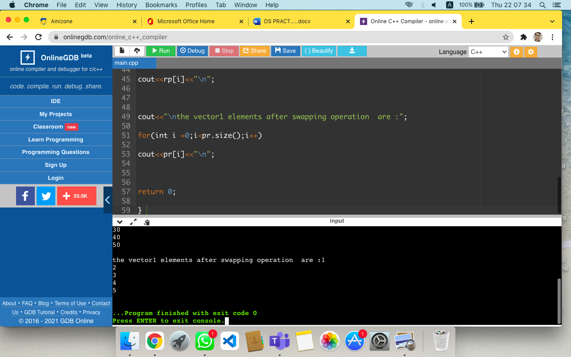

**32ND QUES**

// quick_sort prgrm

#include <iostream>

using namespace std;

void quick_sort(int[],int,int);

int partition(int[],int,int);

int main()

{

int a[50],n,i;

cout<<"How many elements?";

cin>>n;

cout<<"\nEnter array elements:";

for(i=0;i<n;i++)

cin>>a[i];

quick_sort(a,0,n-1);

cout<<"\nArray after sorting:";

for(i=0;i<n;i++)

cout<<a[i]<<" ";

return 0;

}

void quick_sort(int a[],int l,int u)

{

int j;

if(l<u)

{

j=partition(a,l,u);

quick_sort(a,l,j-1);

quick_sort(a,j+1,u);

}

}

int partition(int a[],int l,int u)

{

int v,i,j,temp;

v=a[l];

i=l;

j=u+1;

do

{

do

i++;

while(a[i]<v&&i<=u);

do

j--;

while(v<a[j]);

if(i<j)

{

temp=a[i];

a[i]=a[j];

a[j]=temp;

}

}while(i<j);

a[l]=a[j];

a[j]=v;

return(j);

}

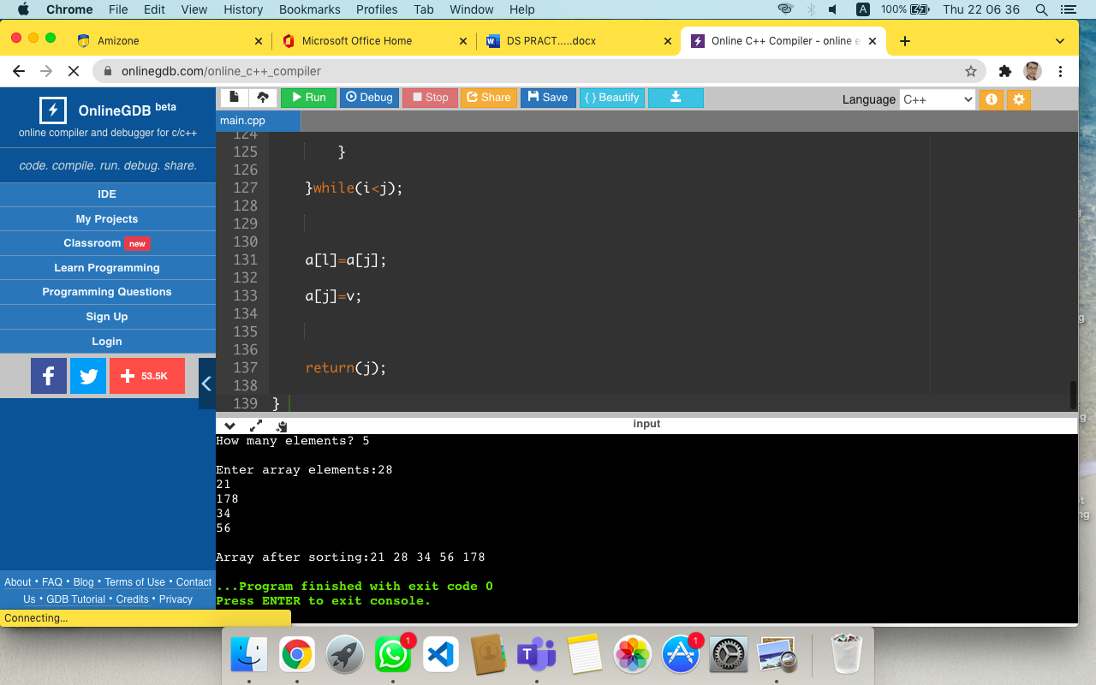

**33RD QUES**

// program for searching operation

#include <iostream>

using namespace std;

int main()

{

int a[50],i,item,n;

cout<<"How many elements do you want ?";

cin>>n;

cout<<"\nEnter array elements:";

for(i=0;i<n;i++)

cin>>a[i];

cout<<"\nEnter item to search :";

cin>>item;

for(i=0;i<=n;i++)

if(item == a[i])

{

cout<<"\n item found at location "<<i++;

break;

}

if(i>n)

cout<<"\n item does not exist";

}

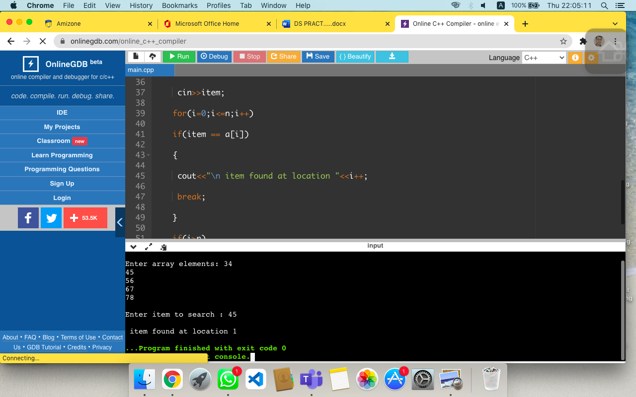

**34TH QUES**

//insertion and inorder display operation

#include <bits/stdc++.h>

using namespace std;

class Node

{

public:

int data;

Node* left;

Node* right;

Node(int d)

{

data = d;

left = NULL;

right = NULL;

}

Node* insert(Node* root, int data)

{

if(root == NULL)

{

return new Node(data);

}

else{

Node* cur;

if(data <= root->data)

{

cur = insert(root->left, data);

root->left = cur;

}

else

{

cur = insert(root->right, data);

root->right = cur;

}

return root;

}

}

//Indorder traversal operation

void inorder(Node* root)

{

if(root == NULL)

return;

inorder(root->left);

cout << root->data << " ";

inorder(root->right);

}

};

int main(){

Node Tree(0);

Node* root = NULL;

cout<<" Enter the Number of nodes to be inserted:";

int t;

cin>>t;

while(t--){

int data;

cout<<"\n enter the elements:";

cin>>data;

root = Tree.insert(root,data);

}

Tree.inorder(root); //for inorder representation

return 0;

}

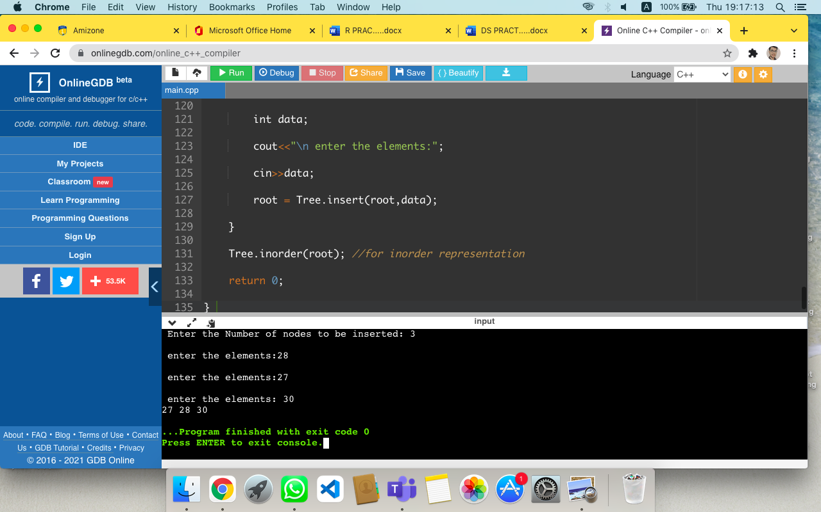

**35TH QUES**

// bst operations

#include <iostream>

using namespace std;

class Node{

public:

int data;

Node* left;

Node* right;

Node(int d){

data = d;

left = NULL;

right = NULL;

}

Node* insert(Node* root, int data) {

if(root == NULL){

return new Node(data);

}

else{

Node* cur;

if(data <= root->data) {

cur = insert(root->left, data);

root->left = cur;

}

else {

cur = insert(root->right, data);

root->right = cur;

}

return root;

}

}

//Indorder traversal

void inorder(Node* root){

if(root == NULL)

return;

inorder(root->left);

cout << root->data << " ";

inorder(root->right);

}

Node* deletenode(Node* root, int k)

{

// Base case

if (root == NULL)

return root;

//If root->data is greater than k then we delete the root's subtree

if(root->data > k){

root->left = deletenode(root->left, k);

return root;

}

else if(root->data < k){

root->right = deletenode(root->right, k);

return root;

}

// If one of the children is empty

if (root->left == NULL) {

Node* temp = root->right;

delete root;

return temp;

}

else if (root->right == NULL) {

Node* temp = root->left;

delete root;

return temp;

}

else {

Node* Parent = root;

// Find successor of the node

Node *succ = root->right;

while (succ->left != NULL) {

Parent = succ;

succ = succ->left;

}

if (Parent != root)

Parent->left = succ->right;

else

Parent->right = succ->right;

// Copy Successor Data

root->data = succ->data;

// Delete Successor and return root

delete succ;

return root;

}

}

};

int main(){

Node Tree(0);

Node* root = NULL;

//Number of nodes to be inserted

int t;

cout<<"enter the number of nodes to be inserted : ";

cin>>t;

while(t--){

int data;

cout<<"enter the element";

cin>>data;

root = Tree.insert(root,data);

}

//inorder traversal

Tree.inorder(root);

// Delete the Node

int delete_data;

cout<<"\n enter the element to be deleted ";

cin>>delete_data;

Node* deleteelement = Tree.deletenode(root,delete_data);

Tree.inorder(root);

return 0;

}

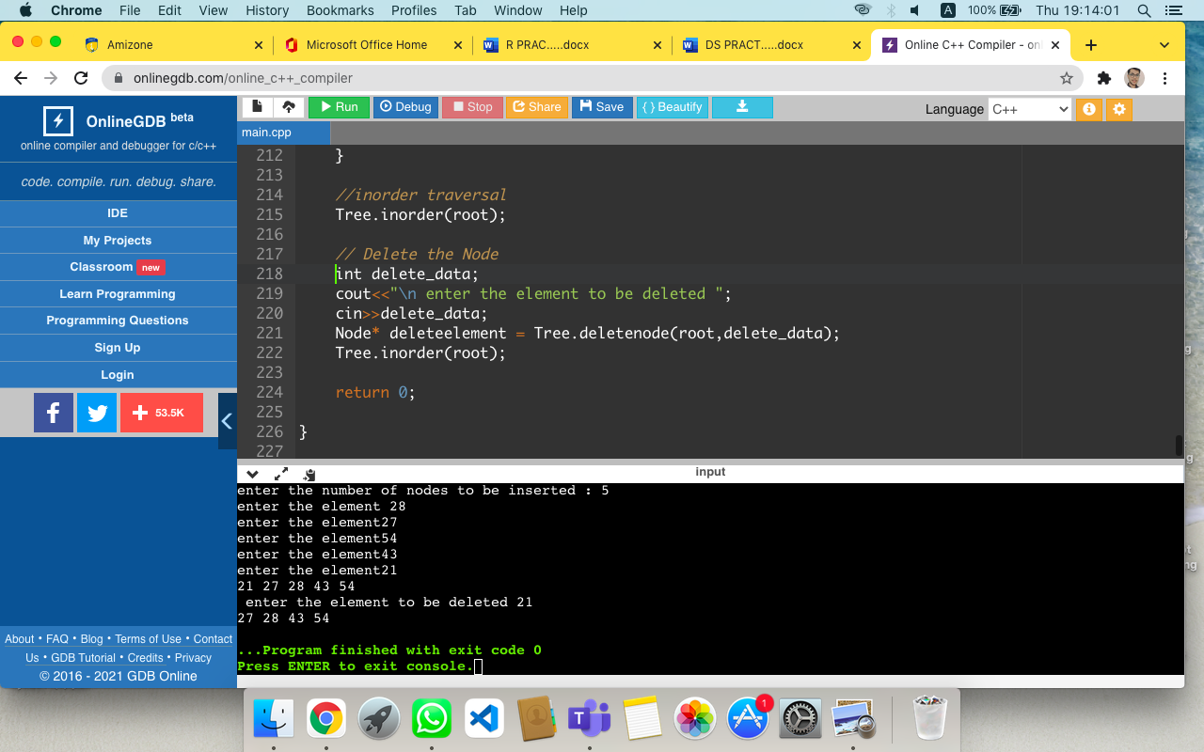

**36TH QUES**

//heap sort program

#include <iostream>

using namespace std;

int N;

void max_heapify(int Arr[],int i , int N)

{

int largest;

int left=2*i;

int right=2*i+1;

if(left <= N && Arr[left]>Arr[i])

largest=left;

else

largest=i;

if(right <= N && Arr[right]>Arr[largest])

largest=right;

if(largest != i)

{

int temp;

temp=Arr[i];

Arr[i]=Arr[largest];

Arr[largest]=temp;

max_heapify(Arr, largest,N);

}

}

void build_maxheap(int Arr[])

{

for(int i =N/2; i>=1; i--)

{

max_heapify(Arr,i,N);

}

}

void heap_sort(int Ar[])

{

int heap_size = N;

build_maxheap(Ar);

for(int i =N; i>=2; i--)

{

int temp;

temp=Ar[1];

Ar[1]=Ar[i];

Ar[i]=temp;

heap_size = heap_size-1;

max_heapify(Ar,1,heap_size);

}

}

int main()

{

int a[10];

cout<<"Enter the size of array :";

cin>>N;

for(int i =1; i<=N; i++)

{

cout<<"\n Enter the values";

cin>>a[i];

}

heap_sort(a);

cout<<"\n Element after sorting are :";

for(int i=1; i<=N; i++)

{

cout<<a[i]<<"\n";

}

return 0;

}

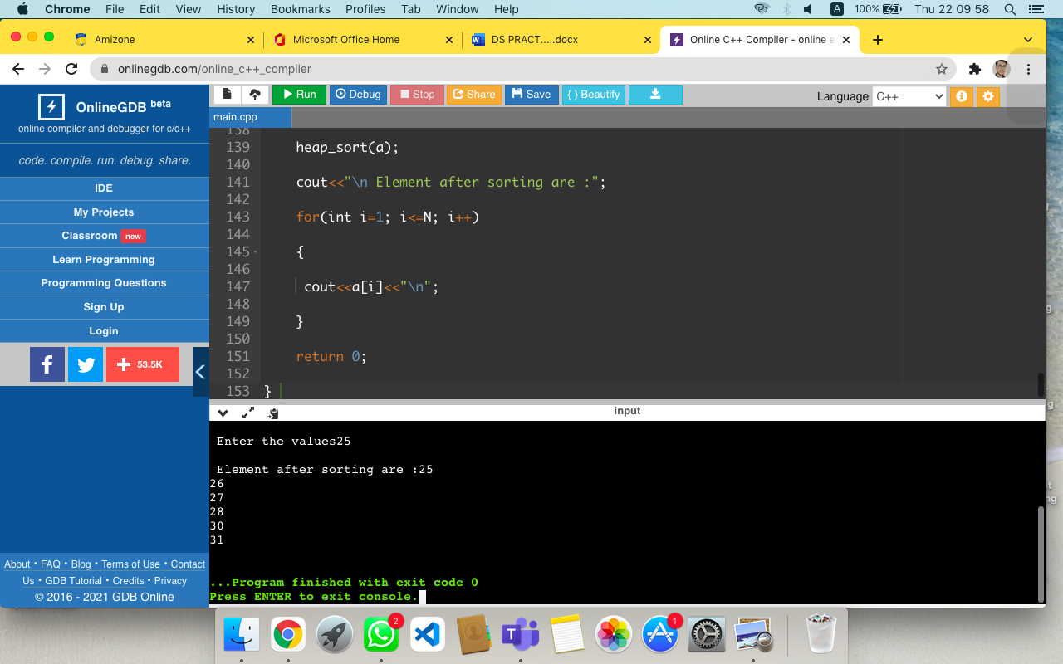

**37TH QUES**